Cila Primary School – Working together to support learning at home
Please have a go at some or all of the activities on the Year 2 Home Learning! You are welcome to present your work on paper or by using Hwb. If you do any work we would LOVE to see it. You can share it via Hwb or email any photos/documents via phillipsc303@hwbcymru.net and evanss527@hwbcymru.net. We try not to upload many attachments for you to print but some of the maths this week will need to be printed if you can.
Keep an eye out for some mystery activities uploaded through the week! Stay safe and Merry Christmas!!!!
Year 2 Focus | Week beginning 14th December 2020
Language, Literacy and communication | Humanities, science and technology, expressive arts,  health & wellbeing
Story writing – Discussion Writing: Please choose from the following (or both!):  - Should Rudolph change the colour of his nose to blue?  - Should Santa come down the chimney?  Can you write a balanced argument ‘for’ and ‘against’ for one of these questions?  Remember:  - Use sentence starters to begin such as “In my opinion…”, “Firstly, I think that…”  - Include 1-3 reasons for each side of the argument  - Include paragraphs if you can  - Include a conclusion. What is your opinion? What do you believe? You could say, “It is clear that…” or “For these reasons I think…”  Please refer back to the discussion writing support sheets uploaded onto the homework section of the class page dated 13.11.20.  Story Writing – The Literacy Shed: Watch the animated clip of ‘The Greatest Gift’: https://www.literacyshed.com/greatestgift.html  - Can you write a Christmas wish letter to Santa? This could be from you or for someone less fortunate than you such as a homeless person.  - Can you create a letter for Mum/Dad /Loved one/Friend telling them how much you appreciate all they do for them throughout the year?  Oracy – Daily photo challenge: the following link has an image of a Christmas cracker. It is meant to get you thinking:  https://www.pobble365.com/christmas-wishes/  Can you click on the link and answer some of the questions under ‘question time!’ There is no need to write the answers down but have a discussion with someone in your house to try and answer them to see what you both think and feel.  On the main page of this website (you do not need to sign up!) you can select a date and it will show you a different image and linked activities to help you write stories. It updates daily so you have lots of images to choose from!! If you want to try some of them out please do so!  Poetry – Can you write a Christmas poem? Here are some examples you can choose to complete:  - An acrostic poem: https://www.bbc.co.uk/bitesize/topics/z4mmn39/articles/ztdvw6f using words like ‘christmas’ or ‘santa’  - Rhyming poem  https://www.bbc.co.uk/bitesize/articles/z9jhqfr  - Colour poem (you do not have to stick to one colour!) https://www.kidspot.com.au/things-to-do/activity-articles/how-to-write-poetry-colour-poems/news-story/dcbe8175bf99e542c87caacc90263784  - Nonsense poem https://www.bbc.co.uk/bitesize/articles/zv3v6g8  - Poem of your choice  We have done some of these in class so watch the videos to remind yourself of what they are. It may just be a poem about what you see when you look out of your window or what your house looks like decorated for Christmas. An illustration is always lovely to go with a poem so please decorate it too.  Spelling, punctuation and grammar – the following website has some great online activities for practising sentence and word work:  http://www.bbc.co.uk/bitesize/subjects/zgkw2hv | Science and Technology – Design your own Christmas jumper/Christmas picture: Can you use JIT5 to design your own Christmas jumpers? Can you make it symmetrical linking to our maths this week?  I know you are all very capable of using Hwb now but follow these steps if you are unsure on how to access it:  - Log in to your Hwb account using your username and password  - Click on the blue j2e button  - On the j2e launch page, find JIT5 and click it  - Click the ‘paint’ tab at the top, right hand side of the page  From here you can create your jumper. You can also use this feature to create a Christmas picture.  Health and Well-being – cosmic yoga: Please use some of your time this week to complete some of the videos on the cosmic yoga you tube page. I know some of you particularly like the minecraft one!  https://www.youtube.com/user/CosmicKidsYoga  Health and Well-being – EPIC Planning: We need your help. Next term our theme is ‘Dwellings’ and we would love to hear your ideas on what you would like to learn about. This is what we call ‘Everyone Plans In Class’. Can you make a little mind map of things you would like to learn about linked to dwellings. A dwelling is where people live. I’m sure you have so many great ideas!!! We will share these when we get back to school in 2021!  Expressive Arts – Nativity Card: – As a Year 2 class, you would normally attend ‘Christmas Wrapped Up’ at Dunvant church where Mr Phil Davies and his team would supply wonderful activities for you all to complete. As it wasn’t possible this year, they have very kindly put together a video for you that includes puppet shows and the story of the nativity. Please use the link below to watch it (its approx 40 minutes long so you know how much time to put aside):  https://youtu.be/1jNu5x79Ulw  They have also provided the resources needed to make a nativity themed Christmas card. These are the plastic wallets you took home on Friday with the red and green card. Please see the photo below and have a go at making it!  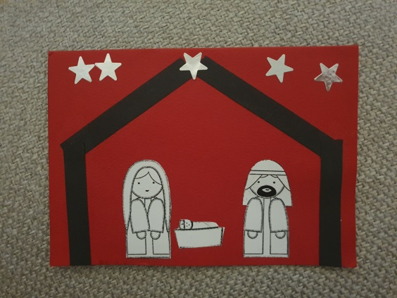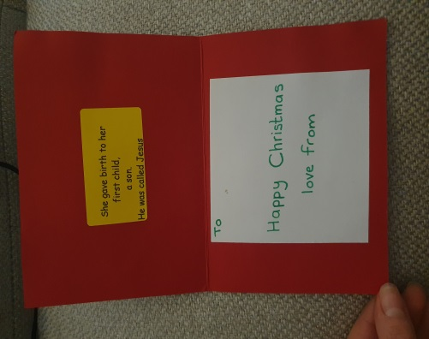  Expressive Arts – Christmas tree decoration: This week in school we would have made some Christmas tree decorations. Can you have a go at doing one at home with things you already have? Please see photos below of some exemplar decorations but use what you can – simply using paper to draw and design, recycled materials like cut up plastic water bottles/egg boxes etc, natural materials from your garden like sticks and pine cones or even by using an old key!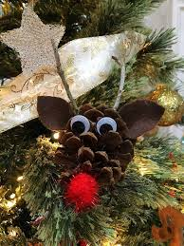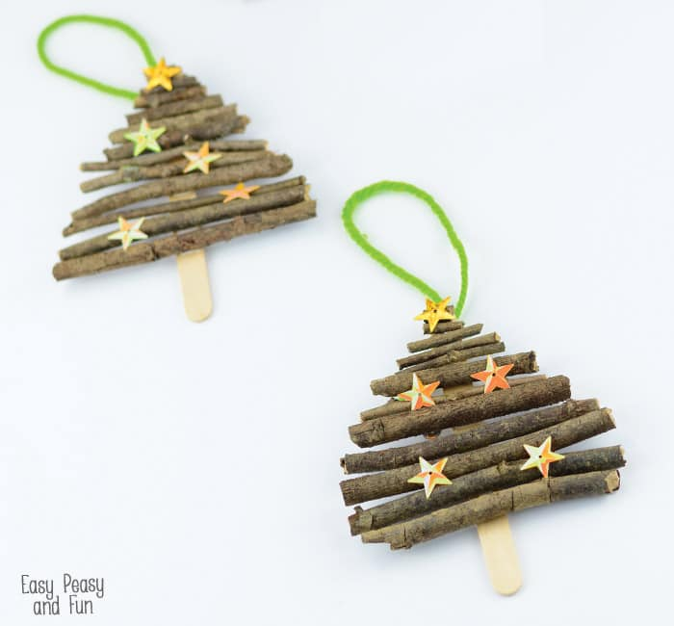  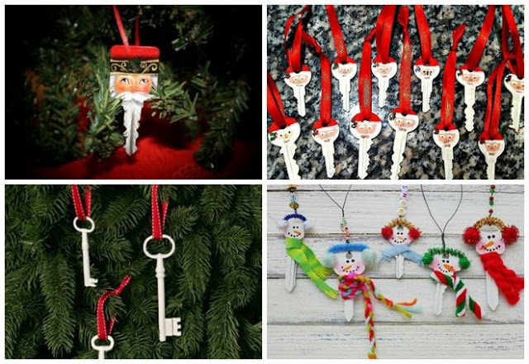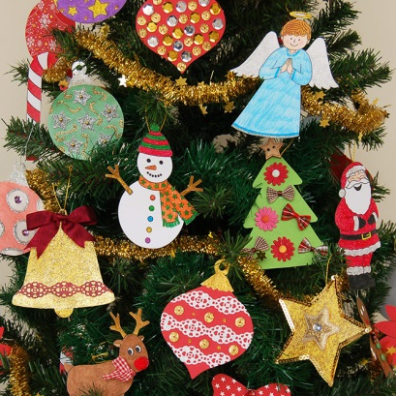  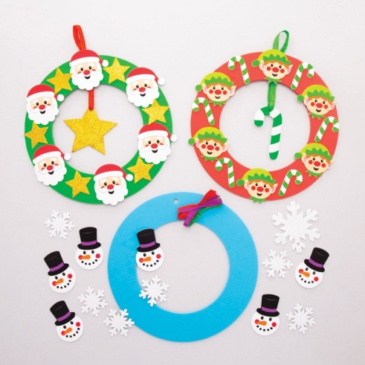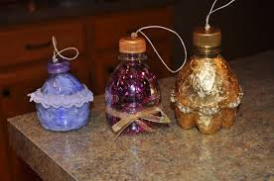
Mathematics and Numeracy
Symmetry – Something is symmetrical when it is the same on both sides. A shape has symmetry if a central dividing line (a mirror line) can be drawn on it, to show that both sides of the shape are exactly the same.

Can you have a go at some of the symmetry activities uploaded on the home learning page? If you don’t have a printer can you create a Christmas themed symmetrical shape of your own like a snowflake?

Measuring – practise your measuring skills around the house. If you have a ruler, use it to measure smaller items (Remember you start measuring from the first line on the ruler marked ‘0’; not the edge of the ruler!) Compare different items. Measure who has the biggest hands in your house. Which is the smallest piece of Lego you have? If you have a measuring tape, you can measure bigger items. Which room is the longest in your house? Build a tower and measure how tall it is.

You can measure in centimetres (cm) and metres (m). It is easier to measure larger items in metres and then centimetres and smaller items in centimetres (and millimetres if you’re really clever!!!) Don’t forget to use these skills when measuring out your tennis court!

Daily Activities
Reading:
- Reading eggs
- Reading books. You can also look at ‘Oxford Reading Owl’ website for a range of exciting reading scheme books.
- Phonics – please recap all phonemes/graphemes. These can be found here: http://www.letters-and-sounds.com/
Mister Teach has some lovely videos on YouTube to recap all the phonics from phase 1 to 5: https://www.youtube.com/channel/UChf0ErPjca3wGIuaBlOrMhg
- ICT games website: https://www.ictgames.com/mobilePage/literacy.html
Maths
- Top marks daily 10 mental maths challenge - choose a level and maths element on the following link: https://www.topmarks.co.uk/maths-games/daily10
- ICT games website: https://www.ictgames.com/mobilePage/index.html
- Abacus activities on https://www.activelearnprimary.co.uk
Welsh Development
- Practise daily patterns/songs in welsh. Lots of games and resources can be found here:
https://www.bbc.co.uk/bitesize/subjects/zqsv7p3
http://www.bbc.co.uk/wales/learning/primary/

Useful Websites:
Hwb: https://hwb.gov.wales/
Abacus: https://www.activelearnprimary.co.uk/login?c=0
Topmarks: https://www.topmarks.co.uk/
ICT Games: https://www.ictgames.com/
Scholastic: https://www.scholastic.co.uk/
BBC bitesize: https://www.bbc.co.uk/bitesize/primary
Twinkl: https://www.twinkl.co.uk/resources/english-medium-schools-welsh-primary-resources/foundation-phase-welsh-primary-resources-classroom-management/school-closures-classroom-management-english-medium-schools-cymru-wales
Oxford Owl: https://home.oxfordowl.co.uk/books/free-ebooks/
Newsround Reports: https://www.bbc.co.uk/newsround
Pobble photographs and linked activities: http://www.pobble365.com
Myleene Class’ Music Lesson: www.youtube.com/channel/UCQh2wgJ5tOrixYBn6jFXsXQ
Maths with Carol Vorderman: https://www.themathsfactor.com
Letters and Sounds: http://www.letters-and-sounds.com/

