Cila Primary School – Working together to support learning at home
Hello Year 2! Please have a go of as many of activities below as you are able to. You are welcome to present your work on paper or by using Hwb. If you do any work we would LOVE to see it. You can share it via Hwb or email any photos/documents via phillipsc303@hwbcymru.net and evanss527@hwbcymru.net. We try not to upload many attachments for you to print but some of the maths this week will need to be printed if you can. If you are unsure of any user names and passwords please email us for them. Please also have look on the class page for explanation videos to accompany some activities.
Year 2 Focus | Fortnight beginning January 11th 2021
Language, Literacy and communication | Humanities, science and technology, expressive arts,  health & wellbeing
Writing.  Information writing.  - This term our writing focus will be information writing. Have a look at the books you have at home and see if you can find any information books. Can you compare it to a fiction (story) book? What do you notice? Can you find things that are similar and things that are different? You do not need to write this down but you can chat about the differences with a grown up or older brothers and sisters. Could you have a go at sorting the fiction and non fiction books you have at home into two groups? Which pile is your favourite?!  - Can you write an information poster about all about you? Have a look at the explanation video to help you with this task. Remember to include the following:  - A heading (All About Me).  - Subheadings  - Information (real facts telling the reader all about you – this could be a description of what you look like and what your likes and dislikes are)  - Pictures/illustrations/photographs  - Captions/Labels  You can do this on J2E or on paper and take photo and email it to us. Please see the ‘supporting documents’ section for a template you could use for the information sheet.  Story writing  Can you write a story about the castle in this picture below?  Think about the following things:  - Who lives here?  - Where is this castle? Is it here or in another land?  - What do you think happens here?  - Why do you think this castle was built?  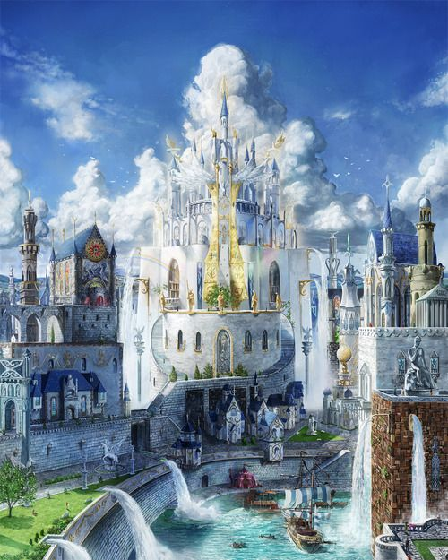  Reading.  Please log in to your reading eggs account daily and have fun completing the activities.  Spelling.  This fortnight we are focussing on two sounds ‘ear’ and ‘air’.  Week 1: ear.  Please click on the link to see Geraldine Giraffe hunt for ‘ear’ words:  https://www.youtube.com/watch?v=EneZ1UubxSA  Week 2: air.  Please click on the link to see Geraldine Giraffe hunt for ‘air’ words:  https://www.youtube.com/watch?v=T3rWZYN5jno  Please check the ‘supporting documents’, section for spelling words ranging from green, to amber, to red (red being the trickiest).  Story.  This fortnight’s story is set in a castle. Please have a look at the recording of the story ‘The Kiss That Missed’ by David Melling.  Welsh.  Please click on the link below to access a BBC bitesize lesson on ‘ble wyt ti’n byw?’ (where do you live?) There is a translate button on the bottom left hand side of the video.  Can you have a go at writing a conversation with your mum or dad based on the short video in the link. You can use J2E or write on paper and email it to us.  https://www.bbc.co.uk/bitesize/topics/z3mt97h/articles/zqs9tv4 | A reminder of how to use J2E.  I know you are all very capable of using Hwb now but follow these steps if you are unsure on how to access it:  - Log in to your Hwb account using your username and password  - Click on the blue j2e button  - On the j2e launch page, find J2E5 and click it  - You will be able to type anywhere on the page  Humanities.  Castles.  - Can you find out about a famous castle from anywhere in the world? Can you make an information poster about the castle? Remember to include all of the features of information writing from the video and include:  - The name of the castle.  - The country where it is from.  - The year it was built (does not have to be exact).  - An interesting fact.  You can present your information in any way you wish – you could use J2E, create a collage or write / draw on paper. Please email us your work as we would love to see it!  - Can you design your dream castle? If you could have your own castle what would it be like? What rooms would you have in the castle? How big would your castle be?  - Can you draw a picture of your dream castle? Include as many details as you can.  - Can you write a description of your dream castle? Remember to use some wow words to describe what your castle looks like. Please have a look at the castle grammar and vocabulary sheet in the supporting documents section for some ideas for ‘wow vocabulary’.  Expressive arts.  - Can you build a castle? You could use lego, blocks, recyclable materials or whatever resources you have at home. We would love for you to send us a picture of what you make!  - Have a go at this YouTube tutorial on how to draw a castle:  https://www.youtube.com/watch?v=QxH9_KrtnUM  Science and technology.  This term we will be looking at materials and how they can change.  Have a look around your home and try to find any object that you can change the shape of by squeezing, stretching or pulling. The object may return back to its shape when you stop squeezing /stretching/pulling it. Why do you think that is? Can you make a list of all the objects you can change the shape of?  Have a go at some of these fun experiments:  https://www.sublimescience.com/free-science-experiments/slimy-ice-chalk/  https://www.sublimescience.com/free-science-experiments/step-through-a-christmas-card/  https://www.sublimescience.com/free-science-experiments/salt-dough/  Health and Wellbeing.  PE with Joe.  The incredible Joe Wickes is back on Mondays, Wednesdays and Fridays at 9:00 AM. Log into Joe Wickes YouTube channel to access his fun PE sessions.  BBC Bitesize  BBc Bitesize have put together a fantastic schedule of online lessons for you to have a go at. Please have a look at the time table and from tomorrow morning you can join in!  https://www.bbc.co.uk/bitesize
Mathematics and Numeracy
Time

Tips for Parents.
Time, particularly digital time, can be quite a tricky concept. Please don’t worry if it takes a while for your child to understand some aspects of this topic – particularly quarter to on a digital clock. This is completely normal. We usually teach time many times in the school year both as a focussed block of lessons as well as incidentally throughout the day when noting various times in the daily routine e,g, playtime, lunchtime etc. As a guideline for how much to complete at a time, in class we would usually complete 1 worksheet on time per day. We always complete analogue work first and then go on to digital. It is also worth your child watching some or all of the explanation video each time they complete one of the worksheets as we would repeat and revise the concepts on a daily basis in class.

Analogue and Digital clocks.

Quarter past.
Please watch the ‘quarter past’ video on the class page.
- Can you complete the analogue worksheet on quarter past?
- Can you complete the digital worksheet on quarter past?

Quarter to.
Please watch the ‘quarter to’ video on the class page.
- Can you complete the analogue worksheet on quarter to?
- Can you complete the digital worksheet on quarter to?

Matching analogue and digital times.
Can you find the times that match and draw a line to the matching times?

Daily routine.
Can you write a daily routine using the times we have been practising? What time do you wake up, have breakfast, etc? You could use the ‘clock template’ on the ‘supporting documents’ page to complete this task.

If you are unable to print out the worksheets, you can complete the tasks by drawing the clocks onto paper.

Abacus Games.

Please log in to your Abacus account to access lots of new maths games that we have uploaded for you.
Daily Activities
- Reading eggs
- Reading books. You can also look at ‘Oxford Reading Owl’ website for a range of exciting reading scheme books.
- Phonics – please recap all phonemes/graphemes. These can be found here: http://www.letters-and-sounds.com/
Mister Teach has some lovely videos on YouTube to recap all the phonics from phase 1 to 5: https://www.youtube.com/channel/UChf0ErPjca3wGIuaBlOrMhg
- ICT games website: https://www.ictgames.com/mobilePage/literacy.html
Maths
- Top marks daily 10 mental maths challenge - choose a level and maths element on the following link: https://www.topmarks.co.uk/maths-games/daily10
- ICT games website: https://www.ictgames.com/mobilePage/index.html
- Abacus activities on https://www.activelearnprimary.co.uk
Welsh Development
- Practise daily patterns/songs in welsh. Lots of games and resources can be found here:
https://www.bbc.co.uk/bitesize/subjects/zqsv7p3
http://www.bbc.co.uk/wales/learning/primary/

Useful Websites:
Hwb: https://hwb.gov.wales/
Abacus: https://www.activelearnprimary.co.uk/login?c=0
Topmarks: https://www.topmarks.co.uk/
ICT Games: https://www.ictgames.com/
Scholastic: https://www.scholastic.co.uk/
BBC bitesize: https://www.bbc.co.uk/bitesize/primary
Twinkl: https://www.twinkl.co.uk/resources/english-medium-schools-welsh-primary-resources/foundation-phase-welsh-primary-resources-classroom-management/school-closures-classroom-management-english-medium-schools-cymru-wales
Oxford Owl: https://home.oxfordowl.co.uk/books/free-ebooks/

