“Welcome,” said Hagrid, “to Diagon Alley.”
He grinned at Harry’s amazement. They stepped through the archway. Harry looked quickly over his shoulder and saw the archway shrink instantly back into solid wall.
The sun shone brightly on a stack of cauldrons outside the nearest shop. Cauldrons – All Sizes – Copper, Brass, Pewter, Silver – Self-stirring – Collapsible said a sign hanging over them.
Harry wished he had about eight more eyes. He turned his head in every direction as they walked up the street, trying to look at everything at once: the shops, the things outside them, the people doing their shopping. A plump woman outside an apothecary was shaking her head as they passed, saying, “Dragon liver, sixteen Sickles an ounce, they’re mad…”
A low, soft hooting came from a dark shop with a sign saying Eyelops Owl Emporium – Tawny, Screech, Barn, Brown and Snowy. Several boys of about Harry’s age had their noses pressed against a window with broomsticks in it.
There were shops selling telescopes and strange silver instruments Harry had never seen before, windows stacked with barrels of bat spleens and eel’s eyes, tottering piles of spell books, quills and rolls of parchment, potion bottles and globes of the moon…
… They bought Harry’s school books in a shop called Flourish and Blotts where the shelves were stacked to the ceiling with books as large as paving stones bound in leather; books the size of postage stamps in covers of silk; books full of peculiar symbols and a few books with nothing in them at all. Even Dudley, who never read anything, would have been wild to get his hands of some of these…
…Hagrid wouldn’t let Harry buy a solid gold cauldron, either (“It says pewter on yer list”), but they got a nice set of scales for weighing potion ingredients and a collapsible brass telescope…
…”Got time for a bite to eat before yer train leaves,” Hagrid said.
He bought Harry a hamburger and they sat down on plastic seats to eat them.
“You all right Harry? Yer very quiet,” said Hagrid.
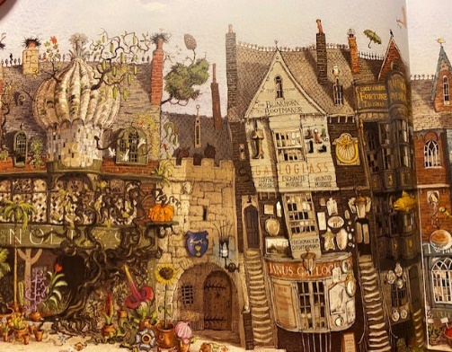
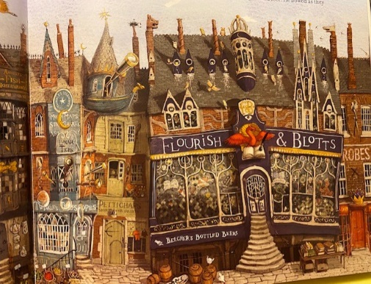
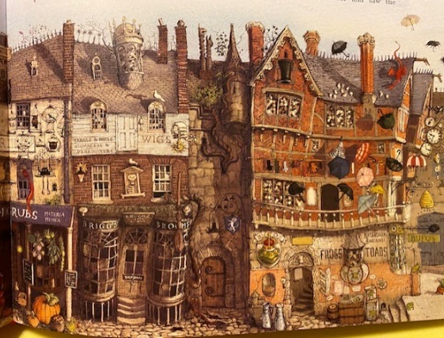
Harry wasn’t sure he could explain. He’d just had the best birthday of his life.

