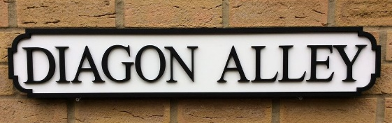
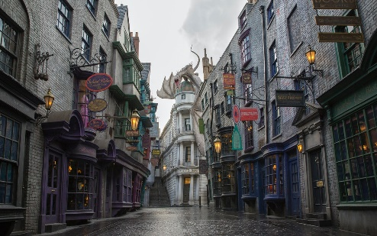
Past Tense Support
Es i… | I went…
i’r… | to the…
i… | to…
Gwelais i… | I saw…
Ces i… | I had…
Bwytais i … | I ate…
Clywais i... | I heard…
Prynais i… | I bought…
Chwaraeais i… | I played..
Darllenais i... | I read…
…gyda… | …with…
fy ffrind | my friend
hud | magic
potiau | potions
poti | potion
dewin | wizard
gwrach | witch
llath | wand
sillafu | spells
tylluanod | owls
llawer o bobl | lots of people
Ces I amser da! | I had a good time!

