Reception/Year 1- Autumn Term (Flight)
Headteacher pages

The children have enjoyed learning about flight this term. To start the term, we recounted the book ‘The Very Hungry Caterpillar’ by Eric Carle. We pretended that we were caterpillars and tried all the fruit the Hungry Caterpillar ate. We also sorted the foods into healthy and non-healthy and described how they tasted. The children did a fantastic job looking after our own class caterpillars and loved observing them turn into butterflies. The children have named the butterflies Dash, Stripes and Bob.
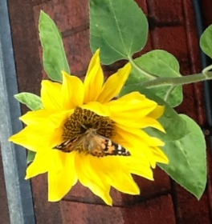
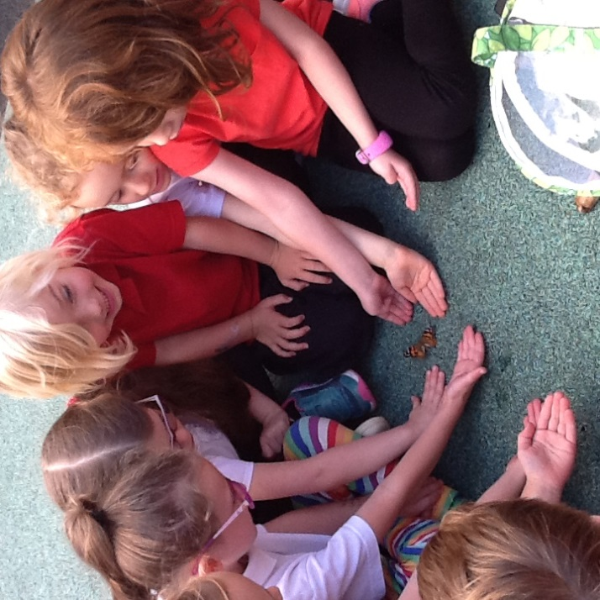

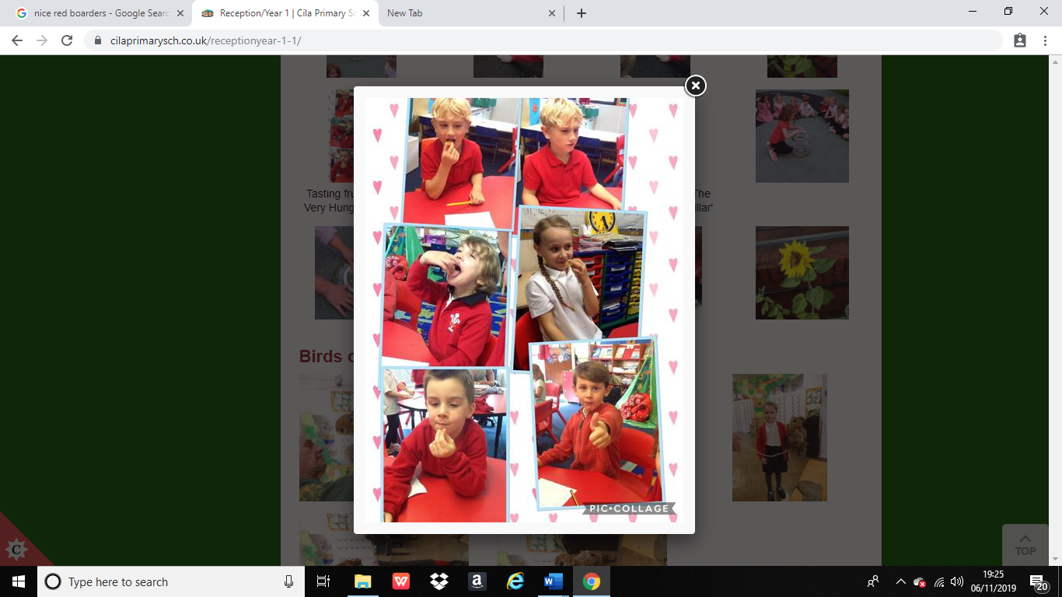
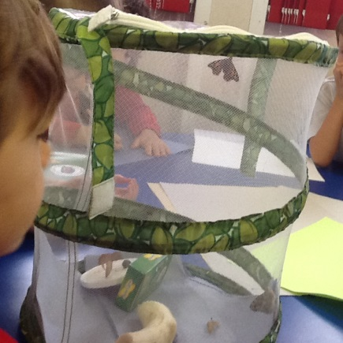

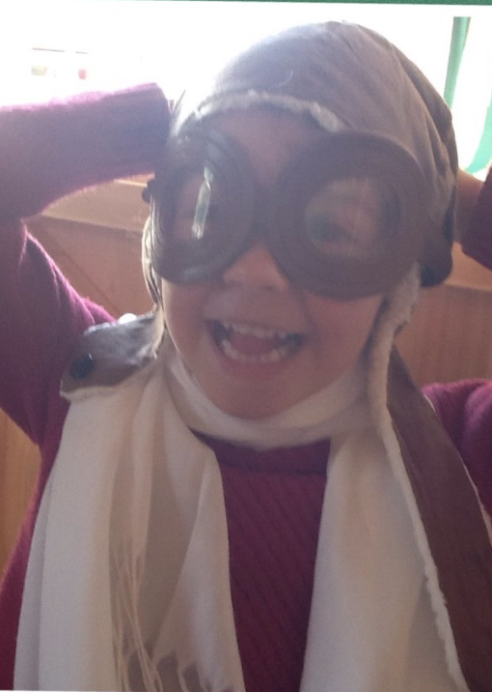
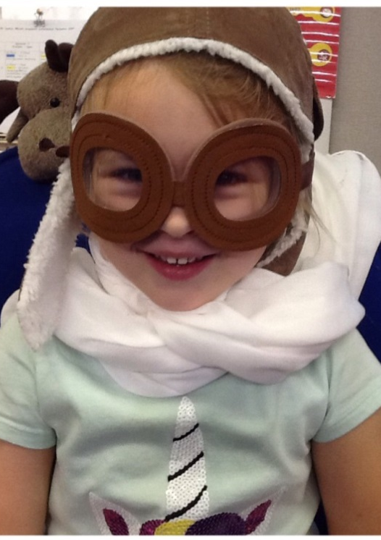
We have also enjoyed learning about aeroplanes and famous people who influenced flight such as the Wright brothers and Amelia Earhart. This is us doing some acting and recounting an adventure we had been on.

We have learned about the festival Diwali and retold the story of Rama and Sita. This is us making our own diva lamps out of salt dough.

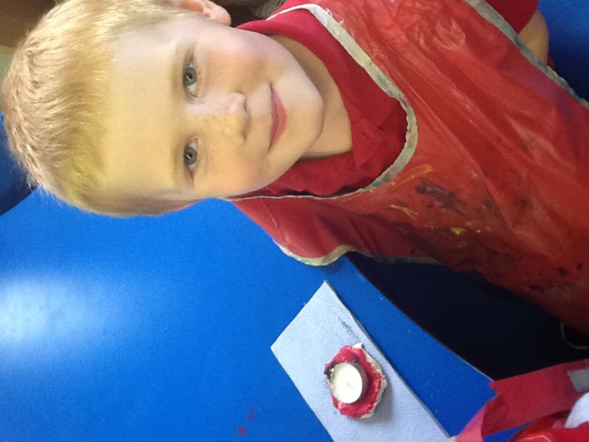
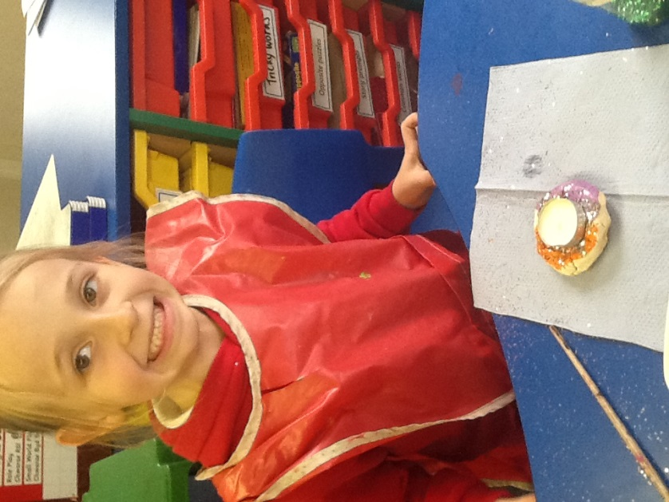

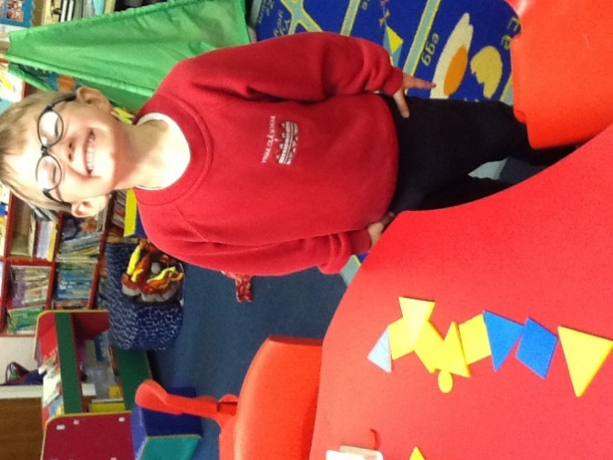
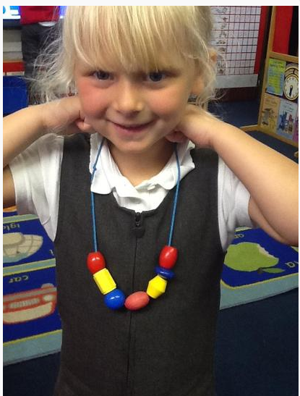
We have done lots of math this term making patterns, sorting objects according to criteria, identifying 2D shapes and adding and taking away.

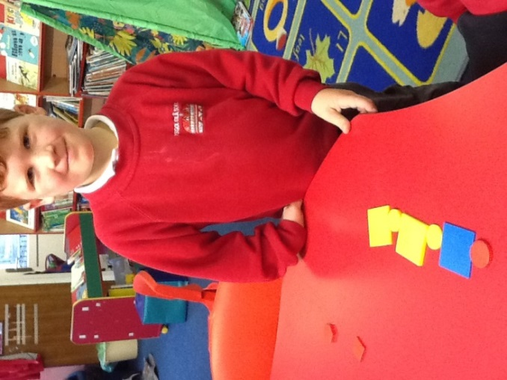
This is us practicing writing our letters in the foam.


