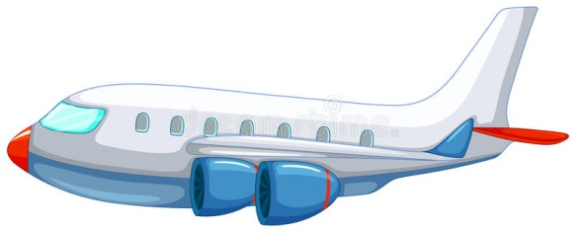
Autumn Term in Nursery
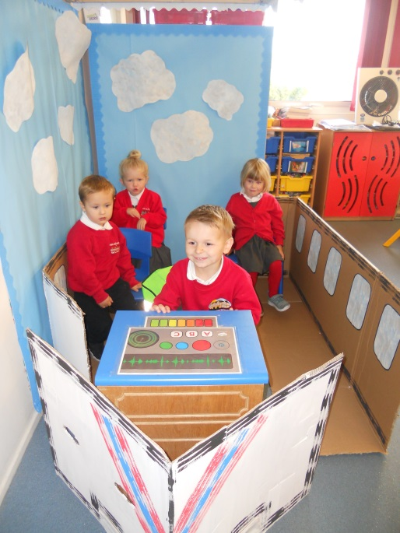
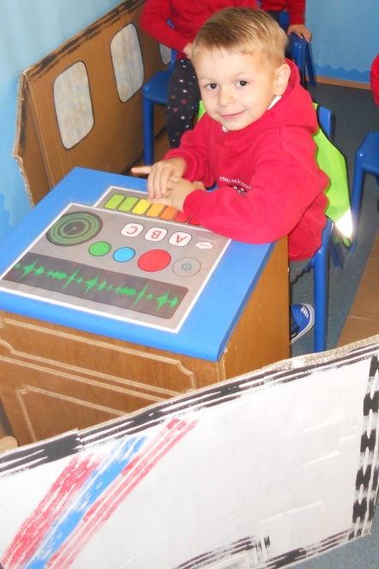
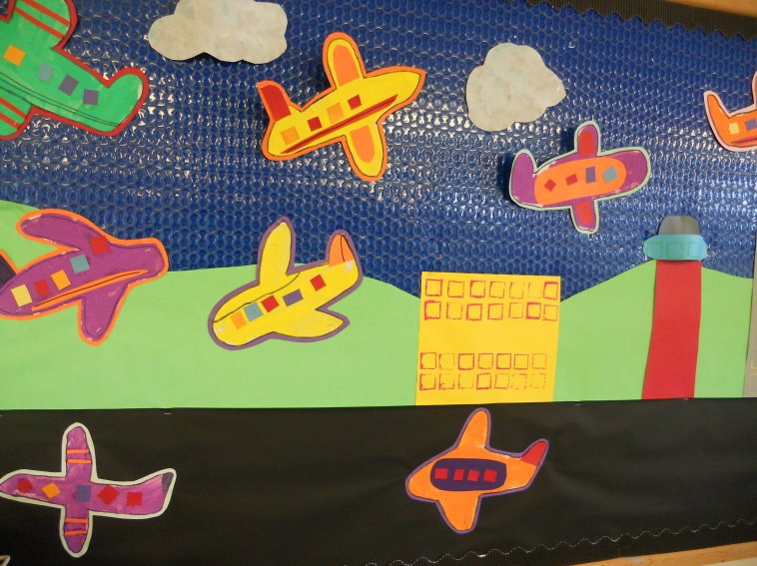
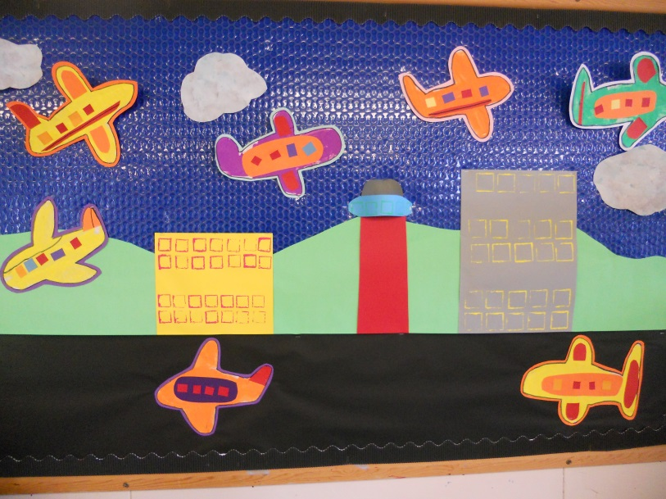
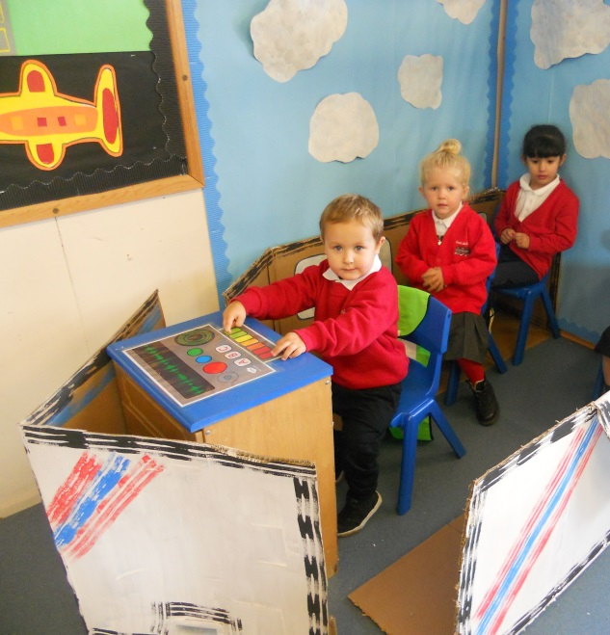
We have been learning about things that fly. We decided to make an airport in our role play area. We have sequenced lots of pictures of ‘Going on holiday’ and ‘Going on a plane.’ We have learnt new words and are trying to use them in the role play and small world areas.

