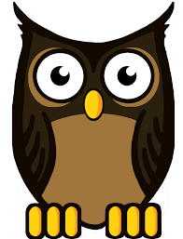
Autumn Term in Nursery
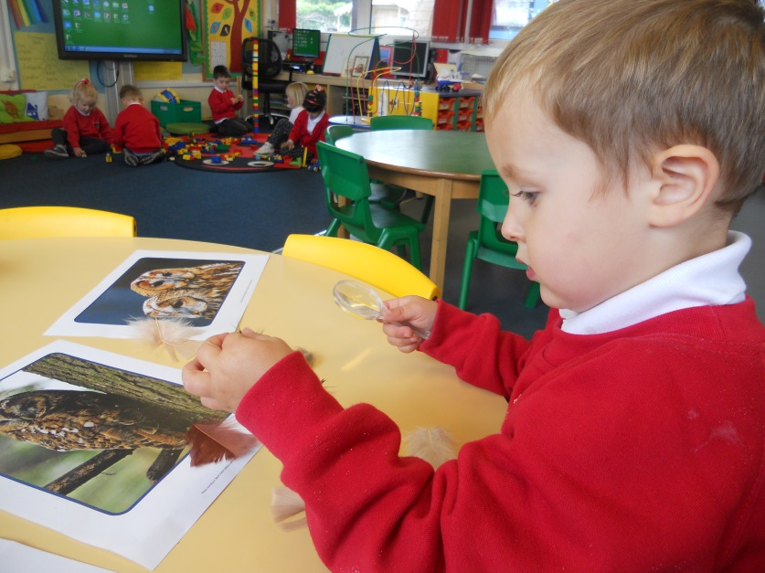
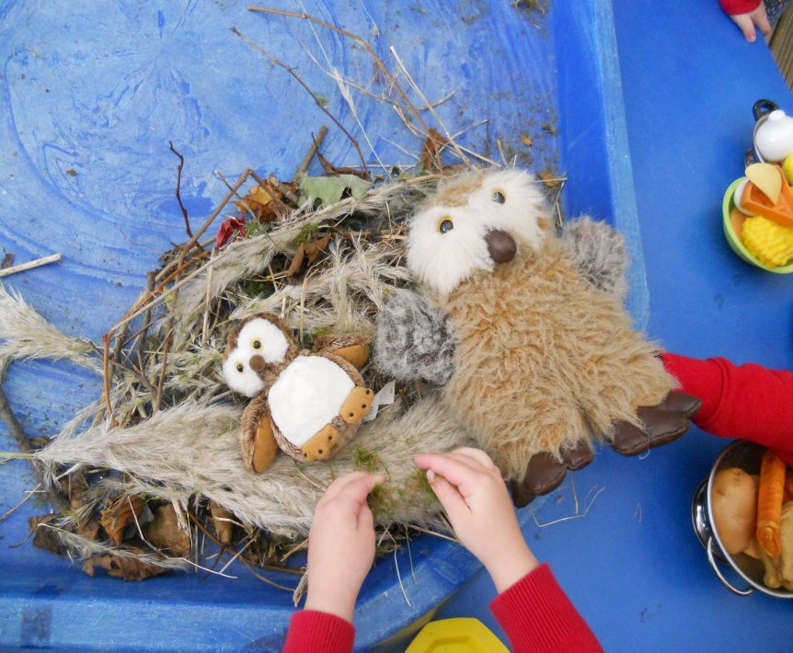
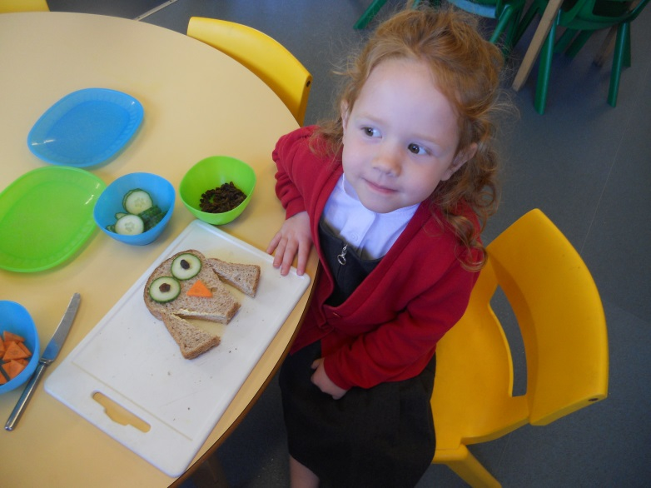
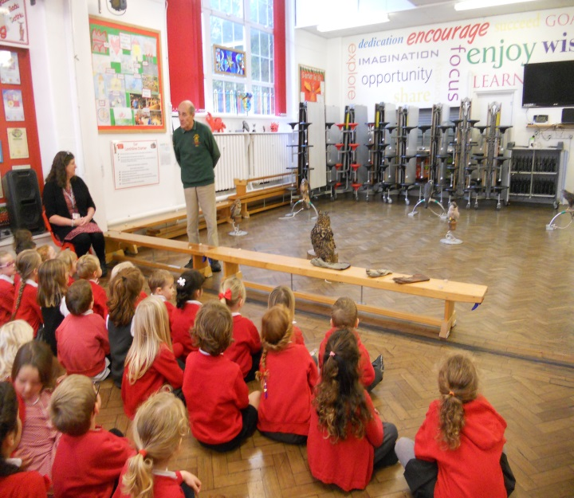
We have been busy this term learning about owls, linked to our theme of flight. The Welsh bird of Prey centre visited school and we got to see a real owl. It was amazing!!! We have read lots of stories about owls, made owl sandwiches and even made a nest for Ollie.

