

Dear Families,

We hope you've had a wonderful Christmas! Our theme for this term is "Good to be me." The children have been engaged in EPIC planning (Everyone Planning In Class) to decide what they'd like to learn about. They had some fantastic ideas, so this term, we'll be learning all about growing up, feelings, our bodies, and what makes us special and unique. You can find the children's EPIC ideas on the Cila website under "Children >> Class Pages >> Nursery."

PE and Water Bottles

PE sessions will take place on Thursday mornings, and children are encouraged to wear their PE kits to school. We encourage the children to put their shoes and socks on by themselves, so any practice you can do at home will be a big help. We kindly request that you send your child to Nursery with a clearly labelled water bottle each day.

Book bags and CAPER books (Children and Parents Enjoy Reading)

School book bags are available for purchase at the school office. Each Thursday, children will choose a CAPER library book to take home, which will be exchanged the following Thursday. New books can only be issued once the previous book has been returned. We hope you enjoy sharing these stories with your child, whether you choose to read aloud or have your child tell the story by looking at the pictures.

Home-school activities

Every Friday, the children will receive a home-school task designed to build upon what they've learned in school and encourage them to share their learning experiences with you. These activities should be returned on Monday mornings.
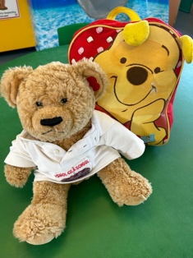
Teddy Cila

TC, our classroom bear, is excited to visit your home one weekend. TC will arrive with his bag and a book and would love to join in your weekend adventures. Please help your child record TC's adventures, whether through drawings or photographs. The class are looking forward to hearing about TC's adventures.

Fruit Snack

Nursery children have time for a snack during the morning. Please provide a piece of fruit for your child each day.

Cooking Money

We kindly request a contribution of £7 to support our cooking and gardening activities. If your child has any allergies or dietary requirements that we should be aware of, please let us know.

Thank you for your support and enthusiasm. We're excited to learn and explore with your children this term. Please feel free to reach out if you have any questions or concerns – morrise500@hwbcymru.net

Best wishes,
Miss Morris and Mrs Hoksbergen.

