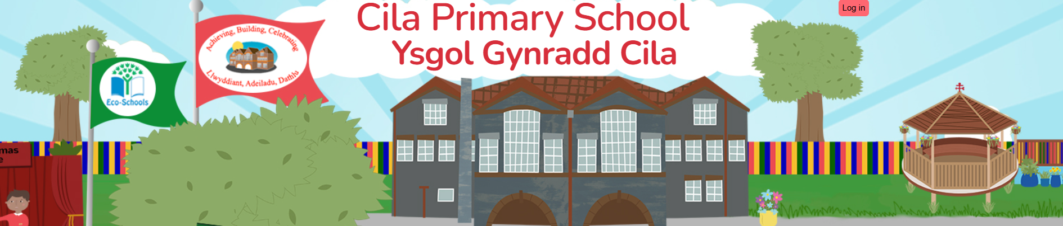
November 2025
Newsletter

Dear Parents,

I hope you all had a wonderful half term break, despite the wet weather. We are now in full preparation for our Christmas productions, so there is lots of excitement in the air as you can imagine.

Christmas Nativity and Pantomime Production

As you are already aware from previous newsletters, our Nativity ‘The Big Little Nativity’ will be performed by our Nursery, Reception and Year 1 children on Tuesday 2nd December at 9.15am. Parents of these pupils will be allocated 2 tickets per family to watch the performance.

Our older children in Year 2, Year 3, Year 4, Year 5 and Year 6 will entertain us with their production of Peter Pan on:
- Tuesday 2nd December at 1.15pm – parents of pupils in Year 2, Year 3, and Year 4.
- Wednesday 3rd December at 1.15pm – parents of pupils in Year 5 and Year 6.

Parents of pupils in Year 2, Year 3 and Year 4 will be allocated 2 tickets for the performance on 2nd December however if you also have a child in Year 5 or Year 6 you will be allocated 2 tickets instead for the 3rd December performance.

This year's production is 'Peter Pan'. Join Peter Pan, the Lost Boys, and Wendy, Michael and John Darling as they encounter predatory pirates, wild warriors, shimmering but shallow mermaids and a crocodile with an insatiable appetite for Captain Hook!

As you can appreciate due to fire regulations, seating in the hall is very limited, hence the ticket allocation of 2 tickets per family, so please do not request any additional tickets as we unfortunately do not have any. Tickets will be available to collect from the school office from Monday 17th November.

Values Education

Our values for this half term are ‘Peace’ and ‘Happiness’. Please let us know if your child demonstrates these values at home.

Rags2Riches4Schools

Cilâ will again be taking part in the Rags2Riches4Schools project on Wednesday November 12th as part of its ‘Eco-School Work’. Green recycling bags can be used and brought to school from Monday 10th November and can be left under the arches. The bags will be collected at 9.15am on Wednesday 12th November by the Rags2Riches4Schools team. Unfortunately, school uniform cannot be accepted. All clothes need to be something you would wear yourself or pass on to friends and family. Check out their website for a list of items they collect www.rags2riches4schools.co.uk/what-we-collect

Roz and Kirsty Photographs – Reminder

Roz and Kirsty will attend school on Wednesday 12th November to take individual photographs of the children. If you are new to the school, please ensure you register to give consent for your child to be photographed. Please ensure your child is wearing school uniform for these photographs. There will be no swimming for our Year 5 and Year 6 pupils on this day.

Cilâ Remembrance Poppy Day

Remembrance Sunday is a National opportunity to remember the service and sacrifice of all those that have defended our freedoms and protected our way of life. We will show our respect on Tuesday November 11th and hope that you will join us in sharing our poppy display along the fence outside school.

Anti-Bullying Week 10th- 14th November

We will again be supporting National Anti-Bullying Week, during which the children will take part in a series of activities to support this year’s theme’ Show Respect’. We will start the week by joining the nation for Odd Socks Day. All you need to do is wear odd socks! It's a great way to celebrate what makes us all unique in Anti-Bullying Week! Odd Socks Day is being held on Tuesday 11th November this year and we are encouraging everyone to wear their odd socks for the day.

BBC Children in Need

Children In Need is being celebrated nationally this year on Friday 14th November. We will support this worthy cause by having a non-school uniform day in return for a coin donation. Please can we kindly ask you to remember that the clothes they choose to wear on the day need to be suitable for them to carry out their normal everyday school activities. (No pyjamas!) Thank you.

Celebration Assembly

Due to the stage being put up in the school hall for our Christmas productions there will be no celebration assembly on Friday November 21st and Friday November 28th. Many thanks for your understanding.

Nursery Trip to The Poundffald Farm, Three Crosses

A Nursery visit to see Santa and the Winter Wonderland at the Poundffald Farm, Three Crosses has been arranged for Friday 5th December.

The elves are waiting excitedly to welcome the children and take them to meet Santa. Once inside, their journey through the snowy land begins. They will see a family of polar bears relaxing in the snow, trees that spring into life and speak, elves busy making toys, and Santa’s sleigh being loaded ready for Christmas Eve.

The cost of the visit is £10.95 per pupil. A parent will need to accompany their child on this visit.
Pupils will need to wear warm showerproof outdoor clothing and wellingtons or suitable footwear.

Consent forms have already been sent home, please sign and return, along with your payment no later than Monday 1st December so that we have an indication of numbers attending the farm.

Christmas Film Club

Would you like childcare for the bargain price of £3.00 to catch up with your Christmas shopping?
To allow parents to start some Christmas shopping, the staff at Cilâ would like to kindly give the children an opportunity to watch a Christmas film together after school. The date for the showing of the film will be Monday December 8th.
Staff have generously offered to donate refreshments for the children, which will include a drink and popcorn. There will be a choice of two films available to view, which will begin straight after school. Film club will end at 5.00pm. Details and a reply slip will be distributed to pupils soon, to return to school, along with a payment of £3.00 ASAP. Those children not wishing to attend will be dismissed at the end of the school day as normal.

Christmas Dinner

Our school Christmas dinner will be held on Thursday 11th December and is available to all children from Reception to Year 6. Halal and vegetarian options are available. Children will eat their Christmas lunch or packed lunch in the hall with their friends. There is no charge for a Christmas lunch.
Please complete the reply slip that will be sent home, stating whether you do, or do not wish to order a Christmas lunch for your child and return by Friday 21st November at the latest. It is important that the slip is returned even if you do not wish to order a Christmas lunch, as our school cook needs to inform the Catering Department, the number of pupils she is catering for.
Please remember to provide your child/ren with a packed lunch on the day, if they do not wish to have a school Christmas lunch.
Wizard of Oz – Youth Edition Gower College

A visit to Gower College, Gorseinon to see the production ‘The Wizard of Oz – Youth Edition’ has been arranged for Friday December 12th for pupils in Reception to Year 6.
We will be leaving school at 9.30am and return in time for lunch. The children will be allowed to bring one small packet of sweets. School uniform must be worn.
The cost of the trip is £7.50. This will include coach travel and the cost of a ticket to the performance. Please sign and return the consent form that will be sent out this week, along with your payment by Monday 8th December to enable us to confirm numbers with both the college and coach company.

