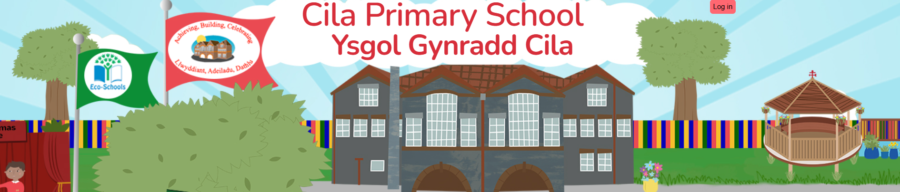
December 2025
Newsletter

Dear Parents/Carers,

Our countdown to Christmas has begun and what a great way to start advent with our Christmas productions this week! All the children were fantastic, a big thank you to them and the staff and yourselves for all your support. It is an extra special time for me this year as it will be my last Christmas here in Cilâ as I will be retiring next year. Since starting my teaching career in 1993, the past 18 years I have had the pleasure to be part of the team here in Cilâ. It has been a truly remarkable and enriching experience, and I am proud of what we have been able to accomplish together. A huge thank you to you all.

BBC Children in Need

Many thanks to parents and friends of the school who helped raise £167.27 for Children in Need. It was great to see Cilâ Primary School being mentioned on the BBC Children in Need programme hosted on November 14th. Well done to everyone.

School Lottery

For our new parents let us introduce you to our school lottery which aims to raise some money to support and improve our children’s learning experiences. Tickets cost £1 with the profits going directly to our school. If you are interested in supporting us then please register as soon as possible for a chance to be a winner! Please follow the link below for additional information and to purchase tickets:

www.yourschoollottery.co.uk/lottery/school/cila-primary-school

Cilâ Christmas Raffle

Again this year, we will be raffling two ‘amazing hampers’ full of Christmas treats!
One hamper will be packed full of items for children including a selection of games, chocolates and Christmas surprises and the other will be filled with Christmas items for parents. Truffle, Swansea have again this year kindly donated a gift voucher for their restaurant. We are very grateful for their generosity.
Ten raffle tickets per family (priced at £1 each). Five yellow tickets for the children’s hamper and five blue tickets for the parents’ hamper were sent home on Thursday. If you wish to purchase these tickets, please tear off and retain one side of the tickets and return the other side with your name and contact number clearly written on the reverse of each ticket along with payment to the yellow box at the main school door by Monday 15th December. The raffle will be drawn during celebration assembly on Friday 19th December. Additional tickets for the hampers can be requested by emailing Mrs. Beech, BeechS9@hwbcymru.net
The Caroler’s Cabin

On Monday December 15th our pupils from Year 3 and Year 4 will be singing in the Caroler’s Cabin in the Christmas Market on Oxford Street between 10.15am and 10.45 am. They will be singing a range of Christmas songs to get everyone into the Christmas Spirit!

Christmas Jumper Day

On Thursday December 11th, we will be encouraging everyone to wear their Christmas jumpers to support ‘Save the Children’. Any coin donations will be greatly appreciated. Children will be allowed to wear their Christmas jumpers from this date until the end of term if they wish to do so. If you have any jumpers at home that your children have outgrown, then please bring them into school to be loved again by someone else. Jumpers can be brought into school from now and will be put out after school each day to go to a new home. Many thanks for your support.

Christmas Film Club Reminder

To allow parents to start some Christmas shopping, the staff at Cilâ would like to kindly give the children an opportunity to watch a Christmas film together after school. The date for the showing of the film will be Monday December 8th.
Staff have generously offered to donate refreshments for the children, which will include a drink and popcorn. There will be a choice of two films available to view, which will begin straight after school. Film club will end at 5.00pm. Details and a reply slip have been distributed to pupils to return to school, along with a payment of £3.00 by Thursday December 4th at the latest. Those children not wishing to attend will be dismissed at the end of the school day as normal.

Christmas Wrapped Up

Pupils in Year 2 will be taking part in ‘Christmas Wrapped Up’ organised by Dunvant Christian Fellowship Group. Pupils will enjoy a selection of Christmas activities at Dunvant Hall on the afternoon of December 17th.

Christmas Parties

We will all be enjoying our Christmas parties on Tuesday 16th December. The children will have an opportunity to play games, dance and have fun with their friends. Fingers crossed, Father Christmas may take time out of his busy schedule to visit our wonderful children at Cilâ. As well as their packed/school lunch, please can you provide an individual plate of food and a drink for your child to enjoy during the party.

Christmas Dinner

Our school Christmas dinner will be held on Thursday 11th December and is available to all children from Reception to Year 6 who have returned their slips to the School office. Please remember to provide a packed lunch if your child is not having a Christmas dinner. All children sit together for our Christmas lunch in the school hall.

Christmas Carols

As the term comes to an end, we would love you to join us to sing Christmas carols at the end of the school day on Thursday 18th December between 3.00pm and 3.30pm. We will keep our fingers crossed for dry weather so that we can come together to end a very busy term and enjoy the tradition of carol singing as a school family. Hopefully our friends from Dunvant Male Voice Choir will be able to join us again.

Swansea City AFC – Free Ticket Opportunity

Swansea City have kindly invited pupils of Cila and their families to grab up to four tickets for Swansea V Portsmouth game on December 9th (7.45PM).Please click on the link below if you would like to attend. https://swanseacity.typeform.com/to/a9eJ0OU3

Dates for Your Diary

We will endeavor to keep you up to date with school activities as they arise.

Date | Activity
5th December | Nursery trip to the Poundffald Farm
8th December | Focus Week – Community Kindness
11th December | Christmas Dinner Day
11th December | Christmas Jumper Day
12th December | Rec - Year 6 Trip to see Wizard of Oz
15th December | Christmas Raffle Tickets to be Returned
15th December | Caroler’s Cabin – Oxford St Swansea Year 3 and Year 4
16th December | Christmas Parties
17th December | Christmas Wrapped Up – Year 2 pupils
18th December | Christmas Carol Singing 3.00pm – 3.30pm
19th December | Christmas Raffle Draw
19th December | End of term
5th January | Return to school – start of the spring term

