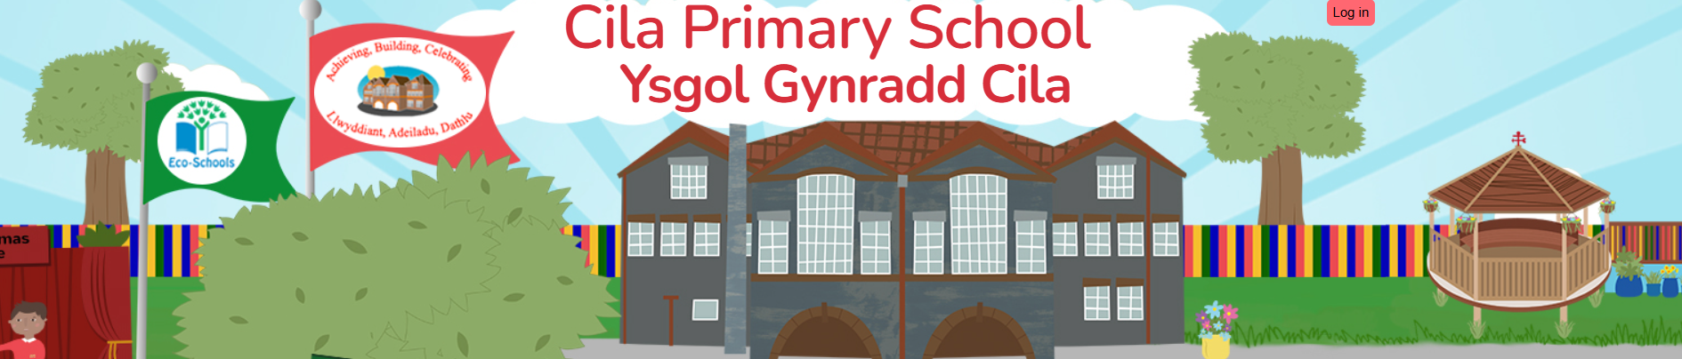
December 2025 (2) Newsletter
Dear Parents/Carers,

The autumn term has come to an end and we are all looking forward to the Christmas holiday. We have had another busy year and looking back over the past twelve months there have been so many highlights to celebrate and enjoy. I hope that our new families who have joined us this term are now settled in and enjoying being part of our school community. Thank you everyone for your endless support and kindness.

Swimming Success!

This term, the Year 5 & Year 6 pupils have been participating in weekly swimming sessions at the Wales National Pool. During these sessions, not only have they been developing their swimming skills, but also increasing their knowledge and understanding of essential water safety and lifesaving skills. We are pleased to share that all pupils have been successful in completing and passing this vital course with Cilâ Primary being the only school in Swansea where all participants have successfully passed. Congratulations Year 5 and Year 6 we are so proud of you all.

Cilâ Community Kindness - Focus Week

The children have certainly showed a greater understanding of the positive feeling that ‘Giving’ can give. We are all so proud of the way in which the children have embraced this with positivity and selflessness. They have all played a vital role in showing others that they care.

Reception and Year 1 children had a lovely afternoon, entertaining community members from Pines Congregational Church with their beautiful singing. It was lovely to see the generations ‘old and young’ enjoying one another’s company. The children shared the Nativity story along with biscuits and cakes with their visitors. One church member said that the visit to the classroom had made his Christmas very special. Nursery children made a card for the church which was greatly received.

Our Year 2 and Year 3 children walked up to Killay precinct and entertained shoppers with their chorus of Christmas songs. They distributed cards, which they had made, full of Christmas wishes to spread kindness and warmth at Christmas time. The children received lots of compliments and thanks for their community kindness.

Our much-loved pets benefitted from the kindness shown from our Year 4 and Year 5 children. They decided to turn their hand to some pet cookery and made a selection of delicious treats for dogs and cats. They delivered their treats to Gower Vets in Upper Killay for animals visiting the surgery. There were lots of wagging tails and happy animals after their visit.

Our Year 6 children shared their kindness a little closer to home by opening a community kindness café in the school hall to show their appreciation to their mums, dads and grandparents. After serving the visitors with teas, coffees and Christmas treats they gifted each person an act of kindness.

Christmas Jumper Day - Save the Children

It was time to put on our Christmas jumpers and help children in the UK and around the world get the best future ever. Thank you for helping us to raise £39.60, to support children facing serious issues like war, hunger and poverty. Your donations will help children get the basics they need most, spreading our kindness worldwide.

Christmas Carol Sing-a-long

We all had an enjoyable time singing carols together to end our school term, despite the weather! A big thank you to you all.

Christmas Raffle

Congratulations to our winners! Many thanks to Truffle, Swansea for their kind donation of a restaurant voucher.

The children’s hamper was won by: The parents’ hamper was won by:
XXXX XXXX

The Truffle, Swansea voucher was won by: The chocolate brownies were won by:
XXXX XXXX

Attendance

To date, 21 pupils have 100% attendance for the autumn term. The winners of the attendance wrist bands for the autumn term are XXXX. As a school, we very much appreciate your support with your children’s attendance.

Fluenz Catch Up Clinics

The School Nursing service has confirmed that there will be catch up clinics being held over Christmas and New Year for any pupils who missed their Fluenz vaccination at school.
Here is the link to book a session:
https://outlook.office.com/book/SBUNasalSprayFluCatchup@wales.nhs.uk/?ismsaljsauthenabled

Spring Term Theme – Good to be me!

We have an exciting topic next term to look forward to, ‘Good to be me!’ It will be led by the Health and Wellbeing area of learning experience in the first half term, then leading to LLC for the second half term. Next term will also see us involved in learning about our role to support ‘National Earth Day’. Look out early next term for the class planning sheet which includes EPIC Planning by the pupils. These planning sheets will also highlight the Literacy and Numeracy focus for the half term.

Swansea City will be returning next term to work with our pupils in Year 4 and Year 5. PE Skills sessions next term will be enjoyed by Year 6. Tennis coaching returns too for our Year 2 and Year 3 pupils. Mrs. Rees will be continuing with her ‘Super Group’ work next term, she will also be teaching in our Reception/Year 1 class each Friday.

Clwb Hwyl for the Spring Term 2026

Our spring term Clwb Hwyl will recommence on Tuesday 13th January 2026 until 4pm. We will continue with the children who attended in the Autumn Term, there is no request to fill in any further consent forms, we are able to continue to use the previous completed forms.

Back to School – Spring Term

School finishes for the autumn term on Friday 19th December and will reopen for pupils on Monday 5th January 2026.

Finally, the festive season is on the doorstep. Christmas is such a special time of year, the opportunity to spend time with our families and taking time to reflect on and appreciate all that we are thankful for. I would like to wish you all a wonderful Christmas break with lots of time for family fun, food and festivities. I always feel privileged that I get to spend part of the Christmas period with the children here at school, the pure joy, innocence, and magic of Christmas for children is simply infectious.
I would like to take this opportunity to wish you all a very Merry Christmas and a Happy New year, and I look forward to seeing you all in the New Year.

