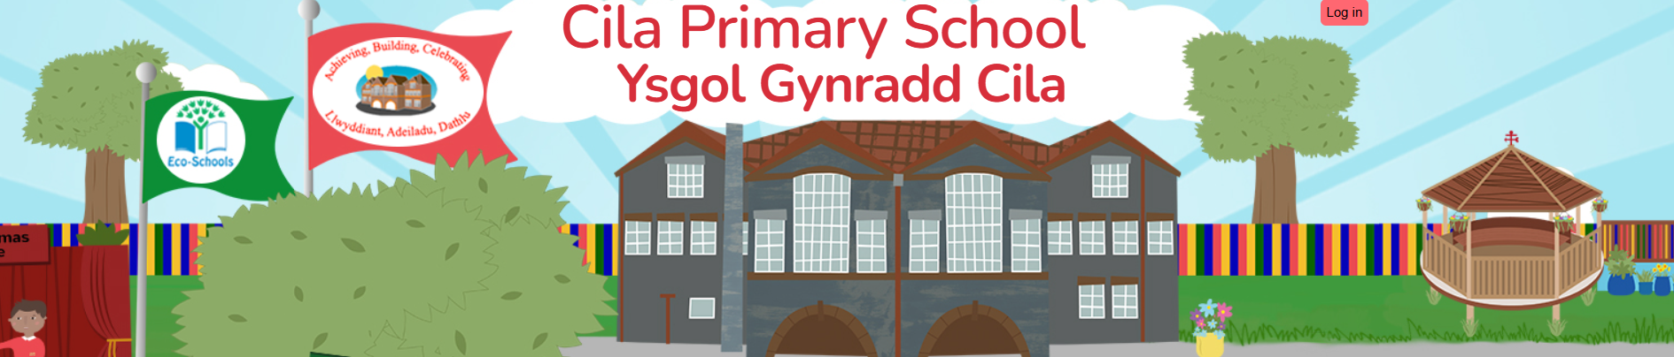
January 2026
Newsletter

Dear Parents/Carers,

A very Happy New Year to everyone! I hope that you all had a good Christmas break, I certainly didn’t think that we would be returning to school in the snow! Thank you for everyone’s cooperation this week in using the gritted paths to and from school. The school yard certainly looked very pretty, a real winter wonderland.

The spring term looks to be a busy one with lots of exciting things planned for us all, including a talk and workshops from Welsh Water, tennis coaching and supporting children’s mental health week. We will keep you informed of any educational visits, visitors and activities on the ‘diary dates’ section of the website, which I am sure will enhance and enrich our curriculum. We have a continuing commitment to providing the best possible education for our children. We greatly value your support and partnership in your child’s learning journey.

Spring Theme – Good to be me!

Our whole school theme for this term is ‘Good to be Me!’ and will be led by the Health and Wellbeing area of learning experience in the first half term, then leading to LLC for the second half term. This term we will also be involved in learning about our role to support ‘National Earth Day’. Class planning sheets which include the EPIC Planning by the pupils will be shared with you shortly. These planning sheets will also highlight the Literacy and Numeracy focus for the half term. Look out for the homework menus soon to be appearing on your child’s class page on the school website.

Our next focus week will take place week beginning, February 9th 2025, during which, the children will explore positive mental health activities to support Children’s Mental Health Week. The theme for this year is ‘This is my Place’. That means feeling like you are part of something, such as your family, your school, your group of friends or a team.
These happy moments help us feel connected, valued, and accepted. When we feel like we belong, we feel happy, safe, and ready to learn and play. It helps us grow strong in our minds and bodies, and it makes it easier to make friends, do well in school, and feel good about ourselves. During Children’s Mental Health Week, we’ll be talking about how we can help everyone feel like they belong. We will share ‘This is my Place’ so we can learn from each other what makes us feel happy. We’ll learn how to be kind, include others, and make sure no one feels left out. Because everyone deserves to feel like they have a place where they are accepted, cared for, and loved. Our mental health flourishes when we feel connected and valued. When children and young people have a strong sense of belonging, they:

- Feel more confident to be themselves and try new things.
- Develop resilience to cope with challenges and setbacks.
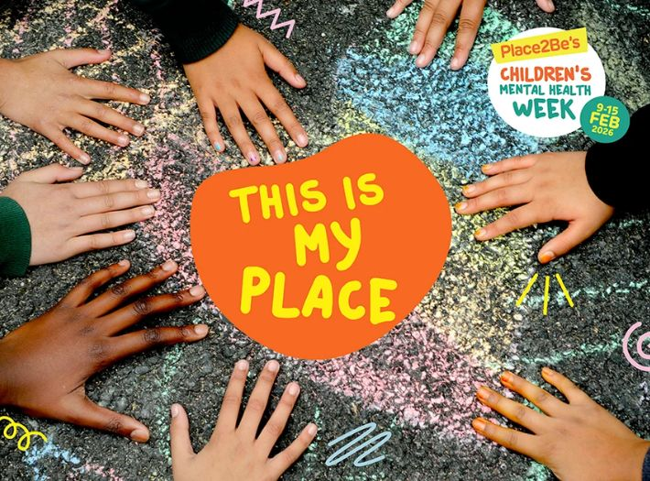
- Build stronger relationships and communication skills.
- Experience less anxiety and loneliness.
- Have better self-esteem and understand their own worth.
- Feel motivated to contribute positively to their communities.

Enriching our Sports Provision

Tom James from Swansea City AFC, Premier League Primary Stars, will be working with our Year 4 and Year 5 pupils this term. Premier League Primary Stars is a national curriculum-linked education programme using the appeal of the Premier League and professional football clubs to inspire children to learn, be active and develop important life skills.

Tennis continues this term coaching our Year 2 and Year 3 pupils and PE skill sessions will be enjoyed by our Year 6 and Year 3 pupils. We are waiting to hear if we have been allocated dates for the cycling proficiency course for our Year 6 pupils. We will keep you posted.

Clwb Hwyl for the Spring Term 2026

Our spring term Clwb Hwyl will recommence on Tuesday 13th January 2026 until 4pm. We will continue with the children who attended in the Autumn Term, there is no request to fill in any further consent forms, we are able to continue to use the previous completed forms.

Safer Internet Day 2025

As a school, we will be supporting Safer Internet Day on Tuesday February 11th. The theme this year is Smart Tech Safe choices.’

Rags2Riches4Schools Collection

Cilâ will again be taking part in the Rags2Riches4Schools project as part of its ‘Eco-School Work’. Please place your clean unwanted items in a bag and leave under the arches by 9.00 am on Friday 13th March, when they will be collected by the Rags2Riches team. Bags may be brought to school from Wednesday 11th March. Unfortunately, school uniform cannot be accepted. All clothes need to be something you would wear yourself or pass on to friends and family. Check out their website for a list of items they collect. www.rags2riches4schools.co.uk/what-we-collect

Parental Consultations

Our “Open Evening” for parents this term will take place on Monday March 16th between 3.30pm and 5pm (11.45am for Nursery parents), you will again have the opportunity to visit your child’s classroom, look at their learning and to chat with their class teacher. If you feel after the open evening that there is still a need to talk to the class teacher again, we will be offering telephone parental consultations. These will take place on the following days only:

Monday 23rd, Tuesday 24th, Wednesday 25th March.

Staff will be unable to make appointments outside of these days. We look forward to welcoming you into school for the open evening.

Half-Term

The school will close for the half-term holiday on Thursday February 12th and re-open for pupils on Monday February 23rd.

INSET

To support you with your future plans, our next INSET days will take place on Friday February 13th and Friday March 27th 2026.

Easter Holiday

The school will close for the Easter break on Thursday March 26th and reopen to pupils on Monday April 13th.

