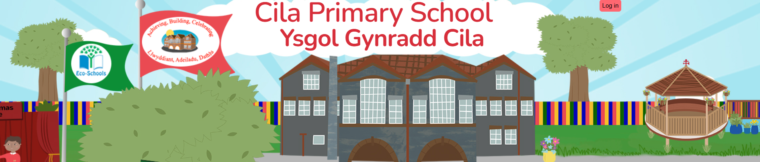
January 2026 (2)
Newsletter

Dear Parents/Carers,

The pupils have all been very engaged with our theme this term ‘Good to be me’ and we have learnt lots of new songs to reinforce it. Ask your children to give you a performance, they have all picked up the words and actions very quickly!

St Dwynwen’s Day

We celebrated St. Dwynwens day on Monday 26th January. We all learnt about the famous Welsh story which was expertly acted out by the Criw.Dwynwen who was the prettiest of King Brychan Brycheiniog's daughters. She fell in love with a local boy called Maelon Dafodrill, but King Brychan had already arranged for her to marry another prince. Maelon took the news badly, so the distraught Dwynwen fled to the woods to weep, and begged God to help her. She was visited by an angel who gave her a sweet potion to help her forget Maelon, which happened to turn him into a block of ice. God then granted Dwynwen three wishes. Her first wish was that Maelon be thawed; her second wish was for God to help all true love; her third wish was that she would never marry. In gratitude, Dwynwen became a nun and set up a convent on Llanddwyn Island, a beautiful little spot on Anglesey.

Holocaust Memorial Day 2026

Holocaust Memorial Day takes place every year on 27 January, and marks the liberation day of Auschwitz-Birkenau, the largest Nazi death camp, in 1945. In the years since, this date has become internationally recognised as the day we remember the six million Jews murdered in the Holocaust.
Our Year 6 pupils took part in an age-appropriate discussion and reflection session to mark this Memorial Day.

BIG School and Garden Birdwatch

A big thank you to our Nursery, Reception and Year 1 pupils who have taken part in the BIG School and Garden Birdwatch this week. Last year, more than half a million people across the UK took part in the RSPB's Big Garden Birdwatch, and spotted more than 9.1 million birds between them.
Data about the types and numbers of birds spotted, gives the charity an enormous amount of information about which birds are doing well, and which ones might be struggling and in need of some extra help.
It's estimated that 38 million birds have been lost from UK skies in the last 60 years.
The data collected by our children this year, helps conservationists understand how to better help protect certain bird species. Diolch Nursery, Reception and Year 1!

Eco Committee

Our school Eco Committee are committed to supporting the school with environmental issues and we thank them for all their hard work, it really is appreciated. Please keep sending in your old batteries to support this initiative.

History, Heritage and Classics Workshops

We are looking forward to working with Swansea University again and welcoming students from the Department of History, Heritage and Classics to work with our pupils in Year 4/5. The students will visit us for one hour a week.

Focus Week – Supporting Children’s Mental Health Week

Our next focus week will take place week beginning, February 9th 2026, during which, the children will explore positive mental health activities to support Children’s Mental Health Week. The theme for this year is ‘This is my Place’. That means feeling like you are part of something, such as your family, your school, your group of friends or a team.
These happy moments help us feel connected, valued, and accepted. When we feel like we belong, we feel happy, safe, and ready to learn and play. It helps us grow strong in our minds and bodies, and it makes it easier to make friends, do well in school, and feel good about ourselves. During Children’s Mental Health Week, we’ll be talking about how we can help everyone feel like they belong. We will share ‘This is my Place’ so we can learn from each other what makes us feel happy. We’ll learn how to be kind, include others, and make sure no one feels left out. Because everyone deserves to feel like they have a place where they are accepted, cared for, and loved. Our mental health flourishes when we feel connected and valued. When children and young people have a strong sense of belonging, they:
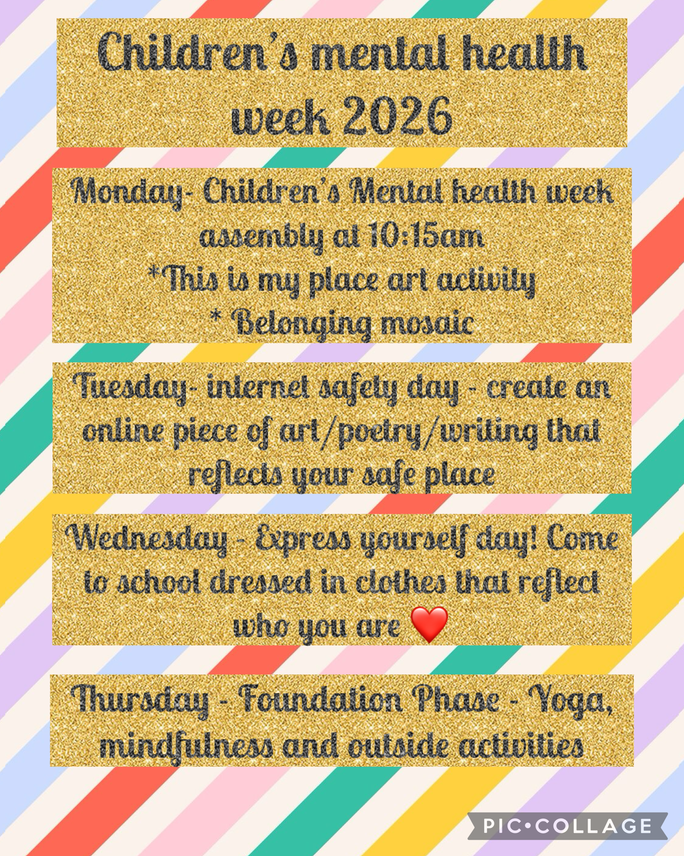
- Feel more confident to be themselves and try new things.
- Develop resilience to cope with challenges and setbacks.
- Build stronger relationships and communication skills.
- Experience less anxiety and loneliness.
- Have better self-esteem and understand their own worth.
- Feel motivated to contribute positively to their communities.

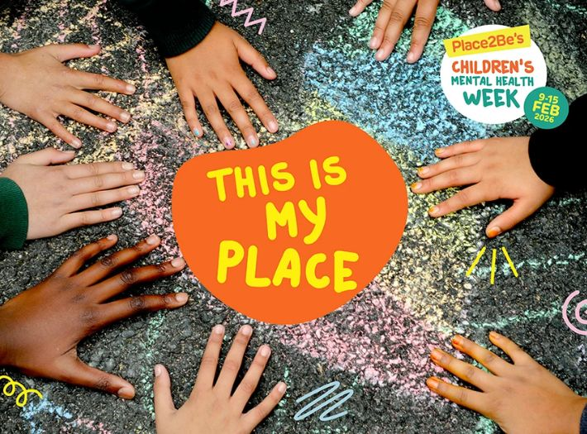

Safer Internet Day 2025

As a school, we will be supporting Safer Internet Day on Tuesday February 10th. The theme this year is ‘Smart Tech Safe choices.’

Rags2Riches4Schools Collection

Cilâ will again be taking part in the Rags2Riches4Schools project as part of its ‘Eco-School Work’. Please place your clean unwanted items in a bag and leave under the arches by 9.00 am on Friday 13th March, when they will be collected by the Rags2Riches team. Bags may be brought to school from Wednesday 11th March. Unfortunately, school uniform cannot be accepted. All clothes need to be something you would wear yourself or pass on to friends and family. Check out their website for a list of items they collect. www.rags2riches4schools.co.uk/what-we-collect

Healthy Eating at Playtimes

As part of our healthy school’s initiative and supporting our work in the Health and Wellbeing AOLE we would like to remind you that if your child brings a snack for morning playtime that it should be a healthy choice. If your child brings grapes to school, then we kindly ask that they are cut appropriately to reduce the chance of choking. We encourage children to bring a water bottle to school daily, which can be refilled at the filtered water machine in the school hall.

Respectful Parking Outside of the School

It has been brought to our attention that some parents are having extreme difficultly when walking their children and pushing their prams to school due to cars being parked on the pavement at drop off and pick up times. We kindly ask that if you need to park outside the school you do so with consideration of pedestrians using the pavement. Many thanks for your support in keeping our school community as safe as possible.

Enhancing our outdoor learning environment with a little music!

We are all looking forward to our new addition of Liberty Bells in the school garden with their vibrant colours and enchanting sounds, these bells will be a great addition to our outdoor learning environment. They will provide an engaging sensory resource and an interactive platform for the children to explore and express their musical creativity. By playing with these bells, children can develop a sense of rhythm and melody, supporting their expressive arts skills and knowledge.

Language Week

We are looking forward to celebrating Language Week after half term 2nd – 6th March. During this week children are welcome to wear their Welsh costumes, Welsh rugby/football shirts or Welsh t-shirts to school. It will also be World Book Day on the 5th March, where pupils are encouraged to come to school dressed as their favourite literary character. We have a jam-packed week planned for pupils to develop their understanding of culture, heritage and ‘cynefin’, as well as broaden their love of literature.

All classes have just taken delivery of a Yoto player (3rd Generation) .This is the ultimate screen-free audio player for children age 3 -12+. Built to inspire imagination and independence, Yoto offers a world of stories, music, learning and adventure in a safe, child-friendly way.

Language Week - ‘Film Club’

This much loved school event will take place on Monday March 2nd at 3.15pm to 5pm. Children will be able to enjoy watching a film linked to language week. Film details and consent forms will be sent out on Friday 6th February. We kindly ask that you return them along with payment by Thursday 12th February if you would like your child to take part. Look out for the posters next week around the school.

Parental Consultations

Our ‘Open Evening’ for parents this term will take place on Monday March 16th between 3.30pm and 5pm (11.45am for Nursery parents), you will again have the opportunity to visit your child’s classroom, look at their learning and to chat with their class teacher. If you feel after the open evening that there is still a need to talk to the class teacher again, we will be offering telephone parental consultations. These will take place on the following days only:

Monday 23rd, Tuesday 24th, Wednesday 25th March.

Staff will be unable to make appointments outside of these days. We look forward to welcoming you into school for the open evening.

Half-Term

The school will close for the half-term holiday on Thursday February 12th and re-open for pupils on Monday February 23rd.

INSET

To support you with your future plans, our next INSET days will take place on Friday February 13th and Friday March 27th 2026.

Easter Holiday

The school will close for the Easter break on Thursday March 26th and reopen to pupils on Monday April 13th.

