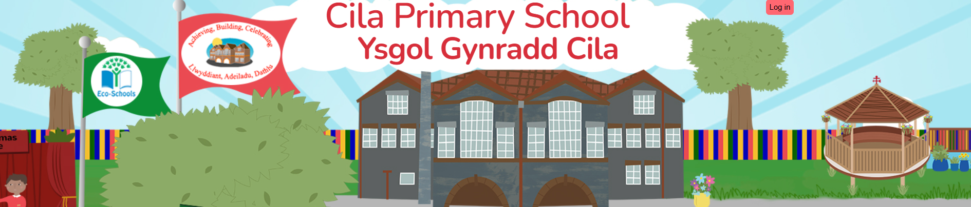
February 2026
Newsletter

Dear Parents/Carers,

Our half term has gone so fast and we find ourselves very quickly getting closer to Easter! The children have embraced our theme this term ‘Good to be me’ and we all certainly enjoyed our Express Yourself Day this week. From yoga and mindfulness to mosaics and safe places, the children have certainly further developed their self-esteem, resilience and a sense of belonging @cila.

Safer Internet Day 2025

Mrs. Evans led our whole school assembly this week, supporting Safer Internet Day and developing the children’s understanding of ‘Smart Tech Safe Choices.’

Language Week

We are looking forward to celebrating Language Week after half term 2nd – 6th March. During this week children are welcome to wear their Welsh costumes, Welsh rugby/football shirts or Welsh t-shirts to school. We have a jam-packed week planned for pupils to develop their understanding of culture, heritage and ‘cynefin’, as well as broaden their love of literature. We will be celebrating St David’s Day on Monday March 2nd. Our film club takes place on this day too. All consents forms have now been returned and numbers finalised for the event.

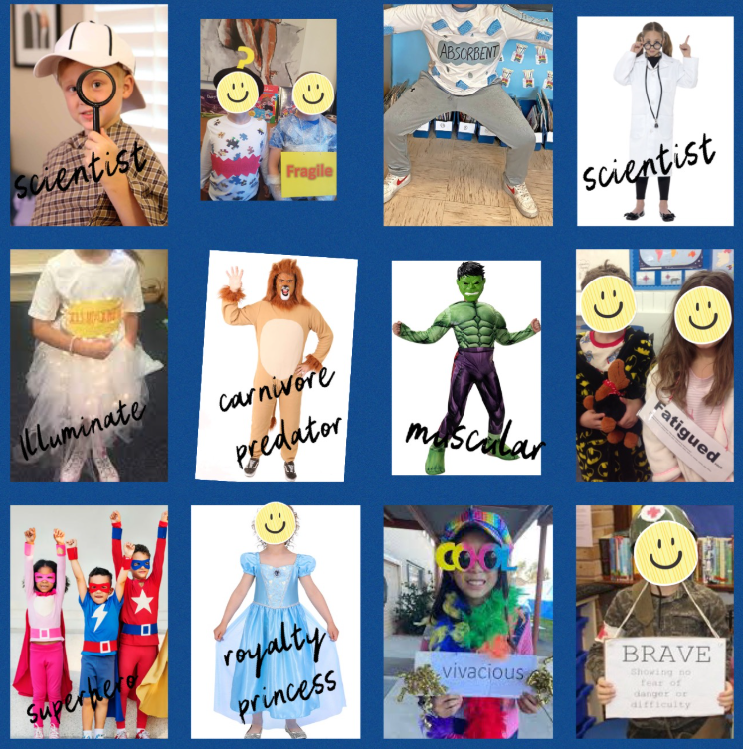
On Thursday 5th March we will be supporting World Book Day. This year, we will be focusing on vocabulary. Therefore, we would like the children to dress up as a word of their choice e.g. vibrant, athletic, heroic, artistic, fragile, mythical, fatigued etc. The list is endless! We would love the children to know their word in Welsh too, to really celebrate vocabulary during our language week! You don’t have to go out and buy anything extra. Please see the pictures opposite for some ideas. If your child already had a World Book Day costume in mind, then they could still dress as a character and choose a word associated with their chosen character. For example, Harry Potter could be associated with the Welsh word 'hudolus' and 'magical'.

If you have any outgrown costumes that you no longer want, please bring them into school after half term so they can be loved again by somebody else!!

St David’s Day

After the success of last year’s Eisteddfod, we have organised another for 2026! We are looking forward to see our talented pupils compete in a range of competitions from photography, music, recitation, singing and dancing. We will be celebrating St David’s Day on Monday March 2nd and children are welcome to wear their Welsh costumes, Welsh rugby/football shirts or Welsh t-shirts to school. Criw Cymraeg will be busy leading Welsh games and activities for all classes on the yard during the day. Children will also have the opportunity to perform some traditional Welsh folk dances.

For more information on the Eisteddfod competitions please visit: https://www.cilaprimarysch.co.uk/cymraeg-9/

Rags2Riches4Schools Collection

Cilâ will again be taking part in the Rags2Riches4Schools project as part of its ‘Eco-School Work’. Please place your clean unwanted items in a bag and leave under the arches by 9.00 am on Friday 13th March, when they will be collected by the Rags2Riches team. Bags may be brought to school from Wednesday 11th March. Unfortunately, school uniform cannot be accepted. All clothes need to be something you would wear yourself or pass on to friends and family. Check out their website for a list of items they collect. www.rags2riches4schools.co.uk/what-we-collect

Sign Language Workshop

Our pupils in Year 5 and Year 6 will take part in an ‘Introduction to Sign Language’ workshop on February 26th.
The workshop delivers a heartfelt, fun and inspiring experience to learn the basics of sign. The children will engage in learning signs for our theme/topics this term so that they can take their new skills and learning into everyday life.

Black History Wales 365 Swansea Launch Music Concert

This week our pupils from Year 3 to Year 6 enjoyed their visit to Swansea Arena with a day filled with live music, community spirit a celebration of heritage.

Mr Phormula Gig

On Monday 9th February our Year 6 pupils visited Sketty Primary School to join other children in our cluster for a Welsh Music Gig featuring Mr Phormula.
Mr Phormula is a Welsh pioneering beat-boxer and live looping artist. His vocal compositions have gained him international recognition as a leading beatboxer, rapper and producer.

Attendance

Congratulations to Year 4/5 for winning the attendance wristbands for the best attendance of 94.3% for the first part of the spring term. Thank you for supporting your child’s attendance by not taking family holidays during term time. We have recently had our half term ‘attendance review’ meeting with our Educational Welfare Officer who closely monitors our pupil’s attendance figures.

IMPORTANT REMINDER: Public Health Wales: Exclusion Period for Common Infections

Now that we are in the midst of the winter months, with lots of different infections circulating, it is timely to remind parents that pupils should not attend schools if they are unwell in order to protect others and prevent the spread of infections. Please be reminded that if your child has been vomiting or has diarrhoea, they should say off school until 48 hours after symptoms have stopped and they are well enough to return.

Clwb Hwyl

Clwyb Hwyl will continue after half term, recommencing on Tuesday 24th February 2026 until 4pm. The club will run until Tuesday 17th March. There are no clubs on Tuesday 24th March due to parental consultations.

INSET

To support you with your future plans, our next INSET day will take place on Friday March 27th 2026.
Our summer INSET Days will take place on Friday July 17th and Monday July 20th 2026.

Easter Holiday

The school will close for the Easter break on Thursday March 26th and reopen to pupils on Monday April 13th. Wishing you all a very happy half term holiday. Enjoy!

