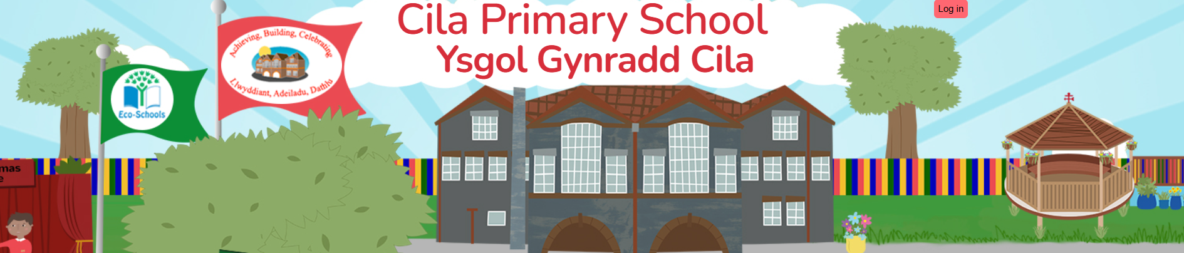
February 2026 (2)
Newsletter

Dear Parents/Carers,
I hope you all had a wonderful half term holiday; the children have been telling us all about their adventures. We are all looking forward to our focus week next week during which the children have a range of exciting activities to get involved in.

Congratulations
Following a rigorous appointment process and interview the governing body selected Mrs. R Wisby to be the new Head Teacher after my retirement next term. We all wish Mrs. Wisby every success and warmly welcome her to the team at Cila. I am positive that she is going to have a wonderful time working with the whole school community.
Language Week

Language week will take place 2nd – 6th March. During this week children are welcome to wear their Welsh costumes, Welsh rugby/football shirts or Welsh t-shirts to school. We have a jam-packed week planned for pupils to develop their understanding of culture, heritage and ‘cynefin’, as well as broaden their love of literature. We will be celebrating St David’s Day on Monday March 2nd.

It is set to be a week full of fun including for example a ‘Tales and Treats’ day, during which pupils will read and listen to stories from pupils in other classes, as well as from members of the community, while enjoying some tasty treats. All classes will be entertaining us during the week with their Welsh singing and discovering a range of Global Greetings. We are looking forward to welcoming the Crow Man back to Cila for some tradition tales and Big Foot arts company to share stories from the mabinogion.

Monday | Eisteddfod and St David’s Day Assembly  Puffin Story Makers Work | The Crow Man  Visit from a Storyteller 1pm - 3pm  Film Club  Diary of a wimpy kid (PG)  Dog Man (U)
Tuesday | Global Greetings | Class Performances  Songs and Poems
Wednesday | Bigfoot Mabinogion Workshops  9am – Year 6  9.45am – Year 2/3  11am – Year 4/5  1.15pm – Reception/Year 1
Thursday | World Book  Day  Dressing up as a word and taking part in a range of activities to celebrate books and stories! | Treats & Tales  Members of the school community will be reading stories and sharing treats with groups of children.
Friday | Twmpath  Traditional Welsh  Dancing | Global Greetings  What have we learnt?

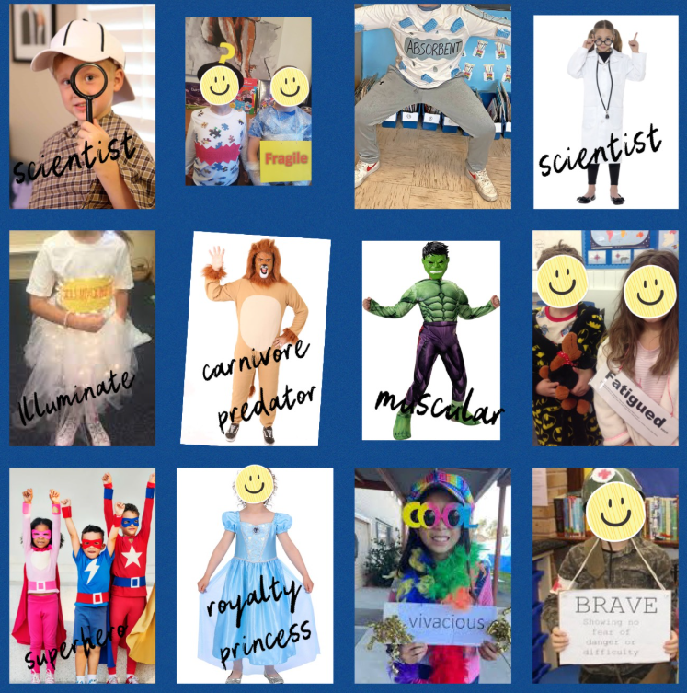
On Thursday 5th March we will be supporting World Book Day. This year, we will be focusing on vocabulary. Therefore, we would like the children to dress up as a word of their choice e.g. vibrant, athletic, heroic, artistic, fragile, mythical, fatigued etc. The list is endless! We would love the children to know their word in Welsh too, to really celebrate vocabulary during our language week! You don’t have to go out and buy anything extra. Please see the pictures opposite for some ideas. If your child already had a World Book Day costume in mind, then they could still dress as a character and choose a word associated with their chosen character. For example, Harry Potter could be associated with the Welsh word 'hudolus' and 'magical'.

If you have any outgrown costumes that you no longer want, please bring them into school after half term so they can be loved again by somebody else!!

Language Week - ‘Film Club’

A reminder that this event will take place on Monday March 2nd at 3.15pm to 5pm. Children attending this event will be dismissed at 5pm from the main entrance of the school. All consent forms and film choices have been received.

Celebration Assembly
This special assembly takes place every Friday morning at the start of the school day and gives us the opportunity to come together as a whole school to celebrate learning, share achievements, reward attendance and values. We encourage the children to share things that they have achieved outside of school as this plays an important part in their development. We also use this time to celebrate birthdays and reinforce our school vision. You are warmly invited to our celebration assembly to see your child sharing for example their swimming certificate, brownie badges or sporting medals and trophies. We kindly ask that you do not bring in hot drinks to assembly.
Tennis Sessions

Mrs E Lightbody from Swansea Tennis Centre will return to Cilâ this half term to coach our pupils in Year 2 and Year 3. Sessions will start on Tuesday March 3rd, fingers crossed for warmer and dryer weather!

Ffa- la- la Dydd Gwyl Dewi Worshops
On Tuesday 10th of March we will be welcoming Ffa-la-la to Cilâ!
For February and March only, Ffa-la-la is touring schools across South Wales with a brand-new interactive workshop designed to bring Welsh culture to life in a way pupils will never forget. They will be using a mix of Ffa-la-la portal songs (built around everyday Welsh patterns) and well-known modern Welsh music to celebrate everything that makes our culture vibrant, joyful and proudly Welsh.
Rags2Riches4Schools Collection

Cilâ will again be taking part in the Rags2Riches4Schools project as part of its ‘Eco-School Work’. Please place your clean unwanted items in a bag and leave under the arches by 9.00 am on Friday 13th March, when they will be collected by the Rags2Riches team. Bags may be brought to school from Wednesday 11th March. Unfortunately, school uniform cannot be accepted. All clothes need to be something you would wear yourself or pass on to friends and family. Check out their website for a list of items they collect. www.rags2riches4schools.co.uk/what-we-collect

Parental Consultations
Our “Open Evening” for parents this term will take place on Monday March 16th between 3.30pm and 5pm (11.45am for Nursery parents). You will again have the opportunity to visit your child’s classroom, look at their learning and to chat with their class teacher. If you feel after the open evening that there is still a need to talk to the class teacher again, we will be offering telephone parental consultations. These will take place on the following days only:
Monday 23rd, Tuesday 24th, Wednesday 25th March.
Staff will be unable to make appointments outside of these days. We look forward to welcoming you into school for the open evening.
Easter

Our Easter celebrations will take place during the last week of term from Monday 23rd – Thursday 26th March.

Monday | The Golden Egg hunt begins!
Tuesday | Y2 Pupils – Easter Cracked up! (Dunvant Christian Fellowship)  Class Easter Egg Hunts
Wednesday | Class Egg Rolling
Thursday | Egg Rolling – Final Roll off  Easter Bonnet/mask Parade
Friday | INSET DAY

INSET

To support you with your future plans, our next INSET day will take place on Friday March 27th 2026.
Our summer INSET Days will take place on Friday July 17th and Monday July 20th 2026.

Easter Holiday

The school will close for the Easter break on Thursday March 26th and reopen to pupils on Monday April 13th.

