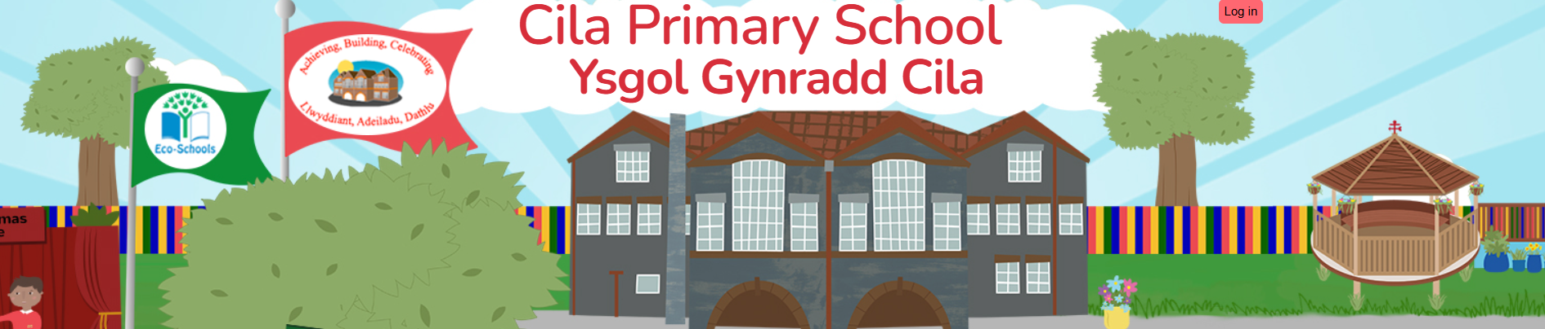
March 2026
Newsletter

Dear Parents/Carers,

As our spring term comes to an end we are all looking forward to our Easter Holiday. This will be the last newsletter of the spring term; on behalf of the children and staff may I thank you for your continued support again this term.

Mr. Paxton Hood-Williams

We sadly heard that our Chair of Governors passed away last Thursday, after a short illness. We are all shocked and deeply saddened by this news. Paxton was a tremendous support to Cilâ Primary School, giving up his time freely to be part of the governing body for such a long time. He was totally committed to his role, always striving for the best possible outcomes for the school and its community. Being a past pupil of Cilâ his heart was always passionate about providing our young people with the best chances in life. He loved a visit to school, especially when he was Lord Mayor of Swansea and he visited our Summer Craft Fair and Garden Party to officially open it. He will be a great loss to us here in school and our thoughts and love go out to his wife and family at this difficult time.

Attendance
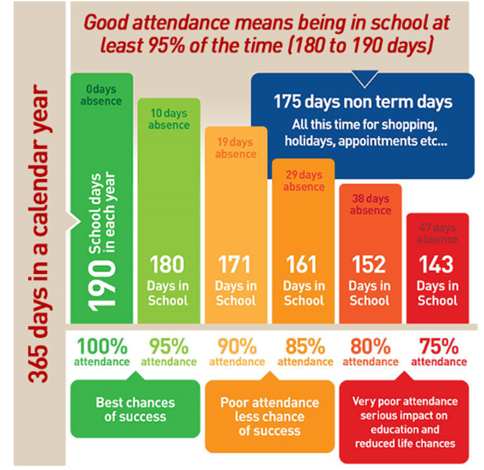
The class with the best attendance for the second part of the spring term is Nursery with 97.9%. Each child received an attendance wrist band in assembly. Thirty children have 100% for the whole of the spring term. This was recognised with each child receiving a certificate of attendance, my congratulations to all of the children who have achieved this.

Currently fourteen children have 100% attendance for the autumn and spring terms for the academic year 2025/26
The winner for the best class attendance each week is announced in our celebration assembly on a Friday and presented with an attendance shield and bear called Dafydd (named by the children) to keep in their class for the following week.
Thank you for your continued support in helping us to encourage good attendance at Cilâ.

Parental Consultations and Open Evening

Many thanks to those parents who attended the open evening last Monday. The children thoroughly enjoyed sharing their learning with you and were very proud to show you their books. Staff have spoken about the positive comments from you as parents about the school, which are always greatly appreciated. Many thanks to you for the continued support that you give the school, you play a vital role in supporting us to create a school environment in which the children are able to thrive and grow.

Easter Celebrations

The children enjoyed hunting for the golden eggs hidden around the school, it has kept them very busy! The Easter colourings made a fantastic spring display in the hall and the masks and bonnets were amazing. I know a lot of work goes into preparing them and the children enjoyed showing them off during our parade.

The winners of the Cilâ Easter egg rolling were as follows:

Nursery Theo
Reception/Year 1 Billy
Year 2/3 Iona
Year 4/5 Jay
Year 6 Myles

Overall winner Myles

Social Media Use Outside of School Reminder

Most social media apps are for pupils 13 years and over, so should not be used by our pupils attending Cilâ Primary School. As you will no doubt be aware, our digital footprint is with us for life and what is posted online, even within private messages, can have a detrimental impact.
If you do allow your child to access social media, we ask for your vigilance. Just like their interactions in person, online interactions require supervision and support. What is right will vary from family to family but some strategies that are known to be successful include:
• Monitoring their phones for the apps that are downloaded
• Enacting parental controls on phones and consoles
• Reviewing the messages they send on platforms and apps – making monitoring part of a daily or weekly routine
• Setting expectations about what space (preferably communal) and times they have access to devices
• Encouraging them to share or discuss with you what they are doing.

It is crucial that we work with you, to ensure that all children are safe on-line. Continuing to closely monitor children’s activities on social media and other on-line sites is very much recommended.
As a school, we continue to speak with and teach the children about the importance of staying safe online and alerting a trusted adult to any worries, concerns and difficulties they might have.
This work includes:
• Continuing, through ICT, Wellbeing lessons and assemblies, to educate children of the dangers of inappropriate use of the internet
• Referring anything that we believe could be defined as, or could potentially lead to, a Child Protection issue to the appropriate external agencies
• Continuing to support you as parents and carers with information. Please find below a helpful link to support you and your child.

https://www.nspcc.org.uk/keeping-children-safe/online-safety/social-media/

Language Week

We all thoroughly enjoyed our focus week. During our language week we got involved in lots of fantastic activities to develop our literary skills. The children particularly enjoyed their Global Greetings challenge and worked together with resilience and patience. We had fun dressing up as words on World Book Day, the children never cease to amaze me with their flare and imagination.

Eisteddfod

A big thank you for supporting our Eisteddfod again this year. The entries were so impressive, it really added a special something to our language week.

Values Education

Our values for next half term are ‘Unity’ and ‘Responsibility’. Please let us know if your child demonstrates these values at home.

Summer Term Theme

Next term our theme will be ‘Achieve, Build, Celebrate’. Our Expressive Arts AOLE will lead our learning. Our focus week next half term will be a ‘Innovation and Creation week’ during which pupils can apply their expressive arts skills.

Summer Term Clubs

Clwb Hwyl will recommence on Tuesday April 21st for children who we have received consent for them to attend. We are able to use the original consent forms received.

Footwear

With summer approaching it is important that children wear appropriate footwear for playing on the yard, using the school playground equipment and P.E. lessons. Inappropriate footwear e.g. flip flops, crocs and sandals can, and does lead to children having accidents.

INSET

To support you with your future plans, our summer INSET Days will take place on Friday July 17th and Monday July 20th 2026.

Easter Holiday

The school will close for the Easter break on Thursday March 26th and reopen to pupils on Monday April 13th. The school will be closed on Monday 4th May due to the bank holiday.

A New Chapter for Cilâ
Since starting my teaching career in 1993, the past 19 years I have had the pleasure to be part of the team here in Cilâ. It has been a truly remarkable and enriching experience, and I am proud of what we have been able to accomplish together.
As you are all aware I will be retiring from my role as Head Teacher here at Cilâ at the end of this term. This has sincerely been one of the best chapters of my professional life, and it has been a privilege to work with members of the governing body, pupils, parents and staff both past and present.
Cilâ Primary School is such a special place, a second home. Having such a fantastic dedicated team to work with each day has been an honour.
I have no doubt that Cilâ will keep reaching new heights with such an incredible group of people working together. Over the years, I’m proud to have been a part of the process of growing Cila Primary School into the wonderful place it is today.
While I look forward to the next chapter of my life, I want to say thank you to you all and to express my gratitude for all your support and kindness. A huge thank you too for all my gifts and retirement well wishes.
I wish you and the rest of the Cilâ team much continued success and all the very best both professionally and personally. I know I will miss you all.
My sincere congratulations go to Mrs. R Wisby, who has been selected to be the new Head Teacher next term. I wish Mrs. Wisby every success and warmly welcome her to the team at Cilâ. I am positive that she is going to have a wonderful time working with such an incredible school community.

