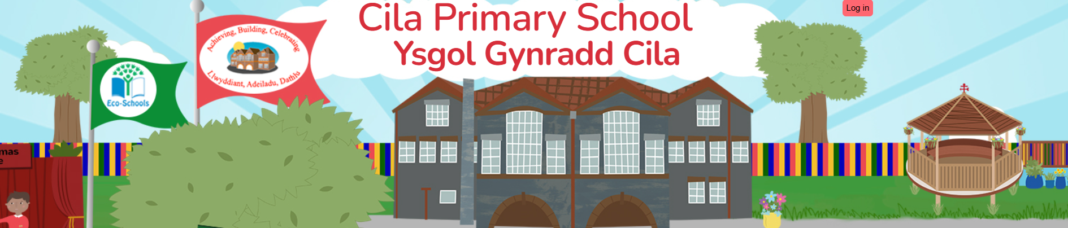
October 2025 (2)
Newsletter

Dear Parents,
As we end our first half term I would like to say a big thank you, for all the support that you have given us. As a school we value the successful relationship between us and understand that this relationship has a long-lasting and beneficial effect on the children's learning and well-being.

Wales In Bloom Awards

Once again, we have been successful in the prestigious Wales In Bloom Awards. Our wonderful school garden has been awarded the highest category this year which is the Level 5 Blooming Award, the only school to achieve the award this year.
We are so proud of our achievement. This year the garden looked particularly wonderful and certainly was a blooming array of colour which attracted lots of compliments and insects too!
We are now getting the garden ready for winter and planting up our bulbs and seasonal bedding plants.

Harvest Donations

Many thanks to you all for your kind donations for our harvest celebrations. We collected a number of boxes of food which have now been shared with the community including, local foods banks and Llys Awen, a supported accommodation project for young adults (16 -21year olds) who are at risk of homelessness or have just left care.

New School Website Update

We apologise for the delay in launching our new school website, which will now go live on 2nd December 2025. We value the importance of timely communication and regular updates of your children's achievements in school and appreciate your patience while the migration continues. In the meantime, we will continue to update our current website to keep you informed on important information.

Focus Week – Technology Week
Our focus week for this half term was ‘Technology Week’. The week involved the children exploring a Rube Goldberg Machine. Each class were involved in setting up a Rube Goldberg Machine then joined the machines together in the school hall to create one big machine which released Rio (our Rights Respecting Reindeer) into the air in his hot air balloon. Everyone had a great time and it was lovely to see the children working together on this rich task.
We ended the week with a “Mad Science” whole school workshop, exploring flight, space and rockets. Atomic Andrew, the presenter was very impressed with our children’s knowledge of space and flight.
School Open Evening
It was so lovely to see so many of you at our school open evening with a record number of families attending the event. It was a real privilege to walk around the classrooms and observe how proud the children were to share their learning with you. It is such a wonderful opportunity for you to see and share all the exciting things that are happening in school. Many thanks for your kind words of thanks and support.

Shwmae / Sumae Day - Hi There

Shwmae / Sumae day was celebrated on Wednesday October 15th, celebrating our wonderful Welsh Language. Many thanks to you for joining in our celebrations. Take a look at the video on our school website, you might recognise a face or two!

Happy Halloween Day

We had a great day today, dancing, singing and enjoying dressing up. A big thank you to everyone for making this a fun day for the children

Battery Recycling Competition

Swansea Council’s recycling team in partnership with the European Recycling Platform (ERP) has continued its school’s battery recycling competition for the new academic year. We have accepted this offer and signed up for the competition which clearly demonstrates our passion for championing important environmental causes such as this.

The school has received a new battery box with liners for collecting batteries ready for a collection at the end of the summer term. The weight of batteries collected by each school in the competition will be recorded with those collecting the highest quantities receiving prizes in the form of amazon gift vouchers. This year we received £30 in amazon vouchers which we have used to support the purchase of magnets for our science investigations.

We need your continued help! You were all amazing last year so please will you continue to support our effort by bringing into school any old batteries and placing them in the collection box in the school foyer. We kindly ask that only adults handle and drop off batteries in the box. For health and Safety reasons please to not send batteries into school in your child’s bag. Diolch!

Values Education

Our values for next term are ‘Peace’ and ‘Happiness’. Please let us know if your child demonstrates these values at home.

Safe Parking and Driving in our School Community

It has been brought to our attention again, concerns about the unsafe parking outside school and the speed of vehicles arriving and leaving the school vicinity. I hope that you would agree that the safety of our children and parents is of paramount importance, and we kindly ask that you travel within the speed restrictions in order to keep pedestrians and other road users as safe as possible. Parking outside the school is restricted and again we kindly ask that you park with consideration to pedestrians and do not obstruct the driveways of neighbouring houses. I hope that we can all work together to promote safety in our school community and thank you all for your support.

Fluenz Vaccination Programme Reception – Year 6 Pupils

The School Nursing Team will be attending Cilâ to administer the Fluenz vaccinations for pupils on Tuesday 11th November. Text messages have been sent to all parents directing them to the school nursing part of our school website for further information. Please click on this link to either consent or notify the school nurse that you do not wish your child to receive the vaccination. It is important that this is completed for every child.
https://forms.office./e/zV0bjq9QNm

Roz and Kirsty Photographs – Reminder

Roz and Kirsty will attend school on Wednesday 12th November to take individual photographs of the children.

Swansea Science Festival – National Waterfront Museum

The Swansea Science Festival, the largest Festival of its kind in Wales, is back!
And it’s set to be bigger and better than ever! Taking place on Saturday 25th and Sunday 26th October 2025, the weekend is packed with discovery, fun, and inspiration for all ages.

They are thrilled to welcome Hamza Yassin, wildlife cameraman and Strictly Come Dancing champion, as one of this year’s star guests. Don’t miss his inspiring talks as he shares stories from behind the lens and his passion for the natural world.
Across the weekend you’ll also find a packed line-up of shows and activities — from the whizzpopping fun of Bubbles and Balloons!, to Super Hero Scientists, and the spectacular Glow with the Flow!
And the best part? It’s the perfect low or no-cost way to spend the half-term weekend together as a family. With dozens of free activities alongside ticketed shows, there’s something for every age to enjoy, whether you’re making, exploring or discovering.
Beyond the stage, a vibrant array of exhibition stands will showcase the groundbreaking research at Swansea University, giving you the chance to explore, experiment, and discover something new.
With over 6,000 people joining us last year, this is a festival you won’t want to miss.

Click the link here for more information and to purchase tickets.

https://www.swansea.ac.uk/swansea-science-festival/

Rags2Riches4Schools

Cilâ will again be taking part in the Rags2Riches4Schools project on Wednesday November 12th as part of its ‘Eco-School Work’. Green recycling bags can be used and brought to school from Monday 10th November and can be left under the arches. The bags will be collected at 9.15am on Wednesday 12th November by the Rags2Riches4Schools team. Unfortunately, school uniform cannot be accepted. All clothes need to be something you would wear yourself or pass on to friends and family. Check out their website for a list of items they collect www.rags2riches4schools.co.uk/what-we-collect

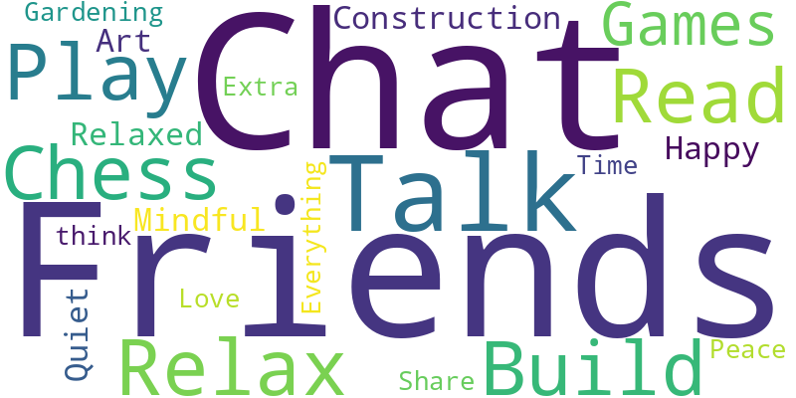
Clwyb Hwyl

Clwyb Hwyl will resume after the half-term break on Tuesday 4th November until 4.00 pm. The last clubs for the autumn term will be on Tuesday 25th November 2025. This new club has proven to be a great success with the children.

BBC Children in Need

Children In Need is being celebrated nationally this year on Friday 14th November. We will support this worthy cause by having a non-school uniform day in return for a coin donation. Please can we kindly ask you to remember that the clothes they choose to wear on the day need to be suitable for them to carry out their normal everyday school activities. (No pyjamas!) Thank you.

Royal British Legion Poppy Appeal

We will continue to put out, alongside the yellow correspondence boxes, a Primary School Poppy Appeal Pack at the start and end of the school day for parents to purchase any items for themselves or their children. The pack contains poppies, snap bands, reflectors and festival bands. All the items are priced as “donation only” therefore no specific price is outlined per item.

INSET-Reminder

A reminder that the school’s next INSET day will be Monday November 3rd .Cilâ will re-open for pupils on Tuesday November 4th at 8.40am.

I hope you all have a wonderful Half Term Holiday; we look forward to welcoming you back to school on Tuesday 4th November.

