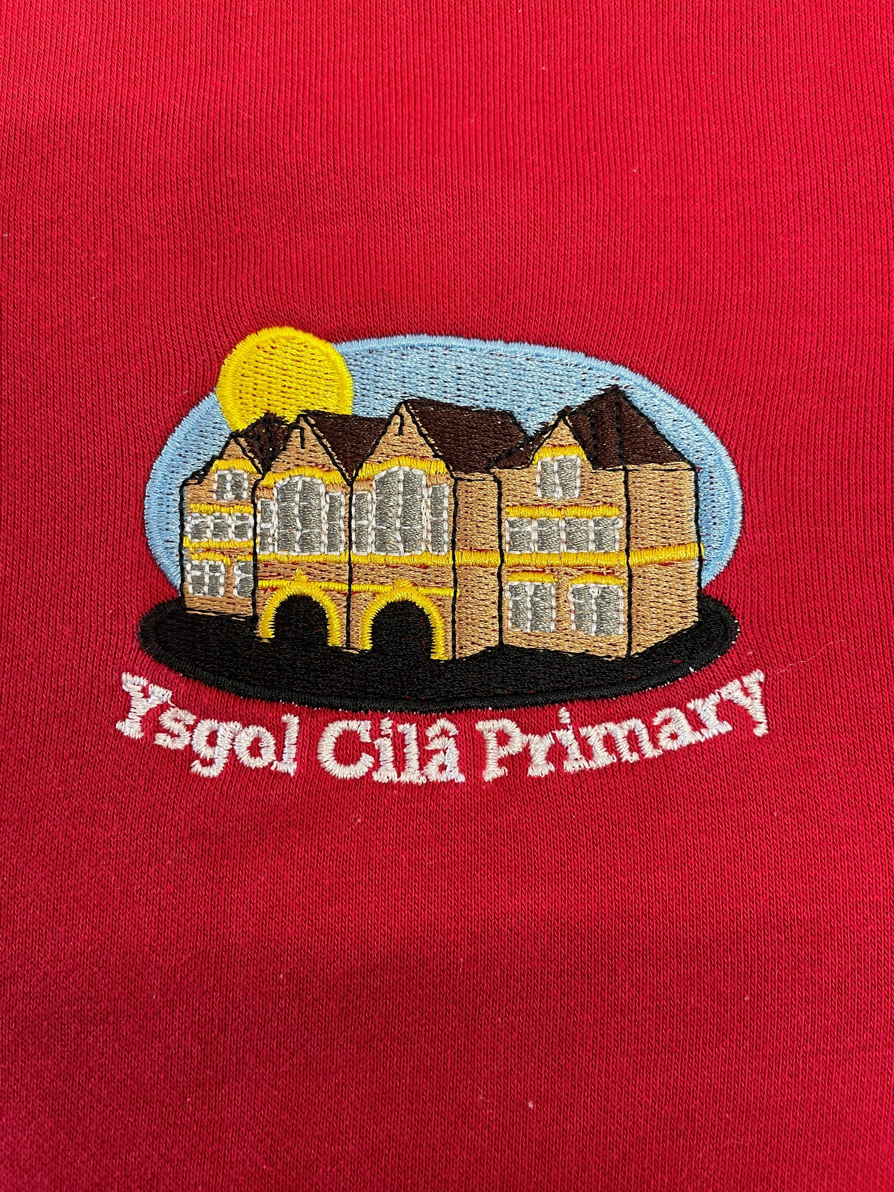
Newsletter

September 2025
Dear Parents/Carer
I hope you all enjoyed your summer holiday and the beautiful weather! It was lovely to welcome you all back to school on Tuesday for the start of a new school year. The children were full of smiles and eager to return to see their friends and teachers. They have all settled into their new classes and are enjoying their new routines. Our congratulations go to Miss Francis who got married during the summer holiday, she has now changed her name to Mrs. Jeffries.
The children are looking forward to the autumn term as they work with each other to plan the terms work with their class teachers. The health and well-being of our pupils, staff and parents will continue to be a driving force in delivering a balanced curriculum to support the needs of our learners.
We wish all our new families a special Cilâ welcome, and we hope they will enjoy their time at Cilâ Primary School. We look forward to working with you. Parents and carers continue to be so supportive of the school and its staff, which is appreciated by us all.
Important Changes to our School Website
Unfortunately, our current school website providers, primary site, are migrating to a new server, Juniper websites. Therefore, we will only have access to our beloved school website for the next week or so. Newsletters will still be uploaded to the current website for the time being, but class teachers will not be updating their class pages until the migration is complete. The school will inform you of any updates via text message in the interim. When the new website is live, it will look different, but the format will be similar. We use this platform for most of our correspondence so we hope to have it active as soon as possible so we can share all of our lovely goings-on. We apologise for any inconvenience this may cause and appreciate your understanding and patience during this transition.
Values
As you know, Cilâ is a ‘Values School’ and we endeavour to ensure that all learners show respect for each other and the school ethos that we endeavour to foster. We constantly remind learners of the Values that underpin our actions and how they impact on a happy and supportive learning environment. Our focus for the first part of the autumn term is ‘Freedom and Respect’. To continue with the work to support our Values Board in the school foyer and hall, we would once again like to ask you for your support. A lot of parents will know that we have Values jars in the school hall. The children discuss the Values in the class with each other, their class teacher and in assembly.
If the children are seen demonstrating the Values, for example Co-operation, Truth, Honesty etc., they are rewarded with a ‘Value Pebble’ which is put in the jar. As the jars fill up, we can measure the Values that we all share in school. Please let us know if your child demonstrates the Value at home in anything they do. A phone call, email or short note/letter would be greatly appreciated.
School Curriculum for the Autumn Term
As part of our Curriculum, we have an exciting range of themes planned for this year, starting with our autumn term theme ‘Off we go!’ The four purposes are the starting point and aspiration for our curriculum design underpinned by integral skills, which are developed within a wide range of learning and teaching. Ultimately, the aim of our school’s curriculum is to support our learners to become:
- ambitious, capable learners, ready to learn throughout their lives
- enterprising, creative contributors, ready to play a full part in life and work
- ethical, informed citizens of Wales and the world
- healthy, confident individuals, ready to lead fulfilling lives as valued members of society
Learning is organised and planned through the six AOLE'S (Areas Of Learning and Experience) which include mathematics and numeracy; science and technology; humanities; languages, literacy and communications; health and wellbeing; and expressive arts.
All classes are involved in EPIC Planning (Everyone Planning In Class) where pupils lead their learning through creating ideas which are displayed on the EPIC board in class. This is where learning is directed thanks to our pupils. You will notice that the half term overview for each class includes some of the EPIC planning questions which have been generated by the pupils.
These will be shared with you as soon as EPIC Planning is completed in each class. The overview will also include our School Value Focus for each half term and our Rights Respecting Focus too.
Technology Week: Our ‘Focus Week’ linked to our rich task activities and planning for this half term will take place, week beginning 6th October 2025.

Swansea City Community Trust – Primary Stars

We are excited to welcome back the Premier League Primary Stars programme to Cilâ this year. The programme focuses on developing the whole child, improving their physical literacy, enhancing their learning and teaching them relevant life skills and behaviours. Our Year 6 pupils will start the programme this half term.

Tennis Sessions

We have again booked tennis coaching sessions for pupils this year. The sessions will take place every Tuesday afternoon and will start with our Reception and Year 1 pupils. Mrs E Lightbody from Swansea Tennis Centre will coach the pupils.

Swimming Lessons

Swimming has started this week for our pupils in Year 5 and Year 6. These lessons will take place each Wednesday during the autumn term.

Safe Parking and Driving in our School Community

It has been brought to our attention again, concerns about the unsafe parking outside school and the speed of vehicles arriving and leaving the school vicinity. I hope that you would agree that the safety of our children and parents is of paramount importance, and we kindly ask that you travel within the speed restrictions in order to keep pedestrians and other road users as safe as possible. Parking outside the school is restricted and again we kindly ask that you park with consideration to pedestrians and do not obstruct the driveways of neighbouring houses. I hope that we can all work together to promote safety in our school community and thank you all for your support.

Correspondence

To support you with the ease of dropping off forms and payments for breakfast club/trips etc. please use the yellow school correspondence boxes which can be found at the main entrance to the school and in the sensory garden, for those using breakfast club. Please refrain from placing correspondence in your child’s school bag, as bags are not checked for these items. All payments should be placed in an envelope, clearly marked with your child’s name, class and reason for payment.

Celebration Assembly
This special assembly takes place every Friday morning at the start of the school day and gives us the opportunity to come together as a whole school to celebrate learning, share achievements, reward attendance and values. We encourage the children to share things that they have achieved outside of school as this plays an important part in their development. We also use this time to celebrate birthdays and reinforce our school vision. You are warmly invited to our celebration assembly to see your child sharing for example their swimming certificate, brownie badges or sporting medals and trophies.
Photographs
The school photographer will attend school on Wednesday November 12th to take individual photographs of the children.

Punctuality
It is important for everyone to be punctual in the morning. Similarly, children must be collected on time, as staff have meetings, training and preparation to attend to, which can only take place once all children have been collected at the end of the school day. If you are experiencing difficulties with punctuality and would like to talk to us about it, please contact the office. Thank you for your understanding regarding this very important matter.
Parental Consultations
This year we will be holding an open evening on Monday 13th Oct 3.30pm until 5pm (11.45am for Nursery parents) to give you an opportunity to visit your child’s classroom, look at their learning and to chat with their class teacher about how they have settled in. If you feel after the open evening that there is a need to talk to the class teacher again, then we will be offering telephone parental consultations. These will take place on the following days only:
Monday 20th, Tuesday 21st, Wednesday 22nd October.
Staff will be unable to make appointments outside of these days.
We look forward to welcoming you into school for the open evening.
INSET / Half-Term Holiday
To assist you in your forward planning, the school’s next INSET day will be Monday November 3rd. The school will close for half-term on Friday October 24th and re-open for pupils on Tuesday November 4th. Cilâ will re-open for pupils on Tuesday November 4th at 8.40am.
The school will close for the Christmas break on Friday December 19th.
Home Time Arrangements/Safeguarding
All children must be collected on time at the end of the school day, by the designated parent/carer. Please ensure your child is aware of the end of school day arrangements, i.e. if they are to wait for an adult to collect them, or they are to go home alone.
Please can you inform the school if arrangements for school collection at the end of the day change, and that you update your collection from school form in line with school policy and procedures. Forms are available on the school website if you need to update it, then return it to the school as soon as possible so we can update our records. We will not allow any child to be dismissed to an adult not listed on the form or allow a child to walk home unless you have informed us of this. Your children’s safety is our main priority and we need an adult to inform us if the pupil is walking home not the child themselves.
School Clubs for the Autumn Term
There is a change this year to our after schools clubs. We would like to introduce you to Clwb Hywl!

Clwb Hwyl will run on a Tuesday from 3.20 to 4pm offering a range of activities for children in Reception to Year 6 to take part in. Children will be able to choose which activity they want to be involved in but also have the flexibility to move between different activities during the session. This allows for children to mix with one another and have a varied selection of choices. There will be a limited amount of spaces available so you will need to return your child’s consent form as soon as possible if they would like to take part. Clwb Hwyl will begin on Tuesday September 16th. Consent forms will be given out on Monday 8th September, to be returned no later than Thursday 11th September. If the demand for the club is greater than our capacity then we will allocate some places before half term and some places after half term. You will be notified of your child’s place if this is the case.

As always, I endeavor to be on the playground each morning and at the end of the school day. You are welcome to come and have a chat. It is always nice to see how people are getting on.
Finally, thank you for your support, and we look forward to another successful year, for your child, for you and our whole school community



Diary Dates
Autumn Term 2025

Please find below diary dates for the forthcoming term. These could be subject to change and will be added to during the term.

September
1st | INSET Day
2nd | Children return to school
3rd | Weekly swimming lessons begin for Year 5 and Year 6
12th | Weekly Swansea City PE/Literacy lessons begin for Year 6
9th | Weekly tennis sessions begin for Rec/Year 1 (half term)
9th | Weekly music coaching begins for Year 2/3
16th | Clwb Hwyl begins (every Tuesday until 4pm)
Date TBC | Year 4, 5 & 6 visit to The Pines Congregational Church, Upper Killay to view Harvest displays
26th | Supporting Macmillan Coffee Morning

October
6th | Technology Week
13th | School Open Day 3.30pm – 5.00pm (11.45am for Nursery parents)
15th | Celebrating ‘Shwmae Day’ – pupils to wear red, green and white to school
16th | Harvest Assembly
20th – 22nd | Parental Consultations
24th | Happy Halloween Celebrations
24th | Break-up for Half Term

November
3rd | INSET Day
4th | Children return to school
10th – 14th | Supporting Anti-Bullying Week
11th | Influenza Vaccinations Rec to Year 6
12th | School Photographs (individual portraits)
12th | Rags2Riches4Schools Collection
14th | Children in Need
25th | Last Clwb Hwyl today

